

**Parent Voice Team Meeting - The Bourne Academy**

**Wednesday 14 September 2022 – 5.30 – 6.40pm**

Actions – in yellow

**Attendance**

**Present:** Hayley Betteridge, Jaqui Brown,Mark Avoth, Caroline Gobell, Cristina Marques, Lisa Cheeseman, Katherine Spicer, Wendy Punal, Lisa Philogene-Jones, Gina Smart, Abbe Bladon.

**Apologies:** none

**Welcome**: to the first meeting of the new academic year, and to HB/JB from the pastoral team.

**Update on Previous Actions (June 2022)**

1. **6th form ball photos in newsletter** – old photos from summer 21! **– CG check and amend.**
2. **Typo in last minutes – CG amend**
3. **Ask again for any old prom dresses and Yr 11 leavers uniform – CG send parent/carer email.**

**Pastoral Update**

1. Miss Lewis back on a phased return and doing so well.
2. Thank you for the fantastic new wardrobes for spare uniform, being kept in the pastoral hub

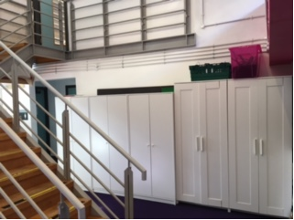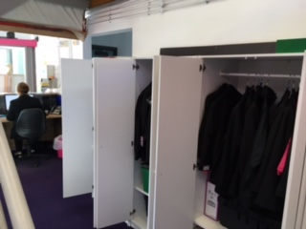

1. Big current push on ATTENDANCE – the ‘Fun Bus’ goes out every morning into the community collecting children to bring them into school
2. There’s been a really lovely start to the new school year and new Yr 7s have done particularly well.

**Principal’s Briefing**

1. **Yr 7s great start –** we are full and oversubscribed, including in year 8. There are only 6 or so spaces in year 9. Yr 7s are having earlier lunches to help them get used to systems, and we are building habits and routines with them. Eg. toilet breaks as suggested by PVT last year.
2. **MiSST –** we did a soft launch to approx. 30 Bourne Scholars in 2021. Now we have fully launched the programme to the new Yr 7s, 180 of them receiving flutes or violins.
3. **Results –** GCSE and A level results were extremely good and showed incredible resilience having endured Covid.
4. **Fully staffed this term –** although there is still the occasional Covid absence.
5. **Outdoor Education Site –** funding from charities to renovate it, almost finished and looks amazing. Contractors just finishing fence around lake.

**Other News**

1. **New Marketing and Comms Officer** – Sarah Price
2. **Open Evening** – next Wednesday 21st September, 6-8pm.

CG ensure there are PVT flyers on the night + enquiry forms, create 3 new social posts to advertise it: Wednesday, Fri 16th, Tuesday 20th

Primary school discussion – Re-send all Open Eve info to two contacts per school and chase by phone.

**Financial Update**

Current bank balance approx £1400.

**CG to finalise bank mandate forms** with **LPJ’s ID verified.**

**Fundraising Requests – No new requests**

Outdoor Education Site - the bird boxes, arranged by Lisa PJ have been fantastic and so much appreciated, thank you.

**PVT Events/Fundraising Ideas:**

1. **Spring Bingo –** let’s get one organised between us all – Lisa PJ may be able to lead (with knowledge from primary school success/£1000 income) with everyone helping: bingo cards, food orders, logistics, chocolate prizes. **CG to put it on November agenda for discussion and planning.**
2. **KPS Christmas Fayre – MA to ask Head Teacher if we can take a stall if they are planning an event**
3. **Open Evening –** Parent information stall – **GS and KS offered to run stall, arrival from 5pm for set up**

**AOB:**

**Yr 11s study time:** Yr 11s can access the site from 8.30am and get a longer study time before school lessons start (unlike other year groups undertaking tutor time activities).

**Homework Clubs:** Can there be scope for an after-school homework club for yrs 9/10/11? (students don’t want to miss out on friendships during lunchtimes for homework). We have created a new slot and **times will be emailed out this week by CG.**

Lockers: new lockers and locks are available for anyone who enquires. **MA check locker.**

**SMHW:** glitching tutor time titles – **MA check**

**Trips:** GS raised query around trips for older students who have missed so much owing to Covid etc. In fact there have been opportunities for all, including Revision trips and DofE trips for anyone in yrs 9/10/11.

**Dates of next meetings**

* Wednesday 9 November 2022: 5.30-6.30pm
* Wednesday 18 January 2023: 5.30-6.30pm
* Wednesday 1 March 2023: 5.30-6.30pm
* Wednesday 26 April 2023: 5.30-6.30pm
* Wednesday 14 June 2023: 5.30-6.30pm