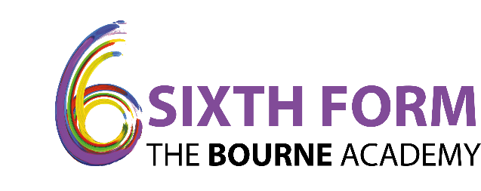

10 March 2021

Dear Parent/Carer,

The second and third 'in-school COVID tests' for 6th Form students will be carried out on Friday 12 March and Wednesday 17 March between the times of 11.30am to 1.30pm (periods 3 and 4).

Please could you ask your child to remain on the Academy site, in the 6th form common room, if they would not usually have lessons and be on the Academy site during these times. Once they have had their test they will be able to leave the Academy site.

Kind regards

**Catherine Turner**

**Business Director**

