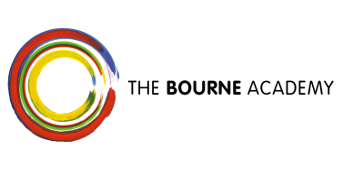

MUSIC AT THE BOURNE ACADEMY

Our aim is to be a centre of excellence for music, promoting and supporting creativity, innovation and high standards of achievement. The facilities and courses available at the Academy provide each student with learning and teaching opportunities which are built around their own individual needs and aspirations. Through the music technology facilities, recording studio, and several performance venues and practise rooms, we aim to provide opportunities for students and other stakeholders to enjoy and appreciate music not only in classroom scenarios but in high standard instrumental tuition and performances by visiting professionals.

Key Stage 3 (Years 7, 8 & 9)
KS3 is taught in mixed abilities and concentrates on the main elements of music through performance, composition and listening and appraising.

Years 7 and 8 have one lesson per week whilst Year 9’s who have opted for music have 2 lessons per week, based on a topic developing the understanding of music through practical tasks or skills which teach the students the skills they require for performance, composing and listening and appraising.

- Year 7 Topics include; African Drumming, Gamelan, Indian Music and Pop Singing
- Year 8 Topics include; Pop Music, The Blues, Minimalism and Reggae and Cubase
- Year 9 Topics include; Ground Bass, Musical Futures Project and Introducing the Recording Studio

Key Stage 4 (Years 10 & 11)
Students who opt for Music at Key Stage 4 will study BTEC Level 2 in Music. The course comprises of 4 modules.

- The Music Industry (100% exam)
- Recording Music (100% Coursework)
- Performing (100% Coursework)
- Managing a Music Product (100 Coursework)

Students will have the opportunity to perform at multiple events as well as recording their own music for a CD released in June each year.
The main focus of the course is for students to gain experience and knowledge in how to earn money in the Music Industry through Performing and Recording.

Key Stage 5 (Years 12 & 13 – 6th Form)
During year 12 and 13 students have the opportunity to continue their studies in music by opting for a BTEC Level 3 Subsidiary Diploma in Music. There are a variety of modules that students can take that focus on performance, events management, theory, improvisation and recording techniques. The students will have the opportunity to perform in the community through a variety of projects as well as gaining valuable experience working alongside professional musicians.

Where Can Music Lead You?

Taking music at Key stage 4/5 can lead into a variety of jobs within the music and performing arts industry, from working in recording studios, theatres, live music venues, record companies, events management and teaching. Students will also gain the necessary skills so they can produce their own music, advertise, promote, design and sell it and their own gigs.

Please email the Subject Leader david.mastrocola@thebourneacademy.com if you have any questions about the curriculum or about your child’s progress during the year.

