Creative Media Production
Teacher: Mr D Williams
Email: danny.williams@thebourneacademy.com
KS4
Course Award: Pearson BTEC Tech Award Level 1/2 in Creative Media Production
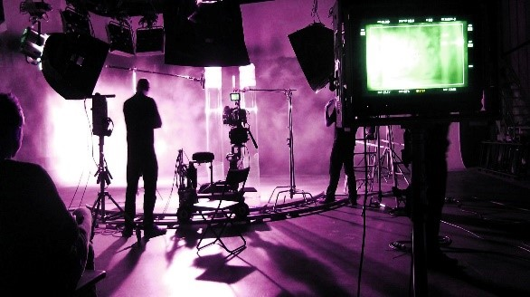
Would you like to experience one of the biggest sectors of the world? Do you want to learn how to create, read and analyse media products? With the new BTEC Tech Award in Creative Media Production, you will get the chance to develop valuable skills and techniques in different disciplines, produce a practical response to a digital media brief, and explore potential careers in the industry. This course is great for anyone who is not 100% certain about what they want to do in the future. By having this qualification, your career path could be opened to many different jobs within the industry.
What will I study?
Essentially you will learn how the media sector works. The creative media sector is a dynamic, growing and rewarding industry. It is now worth over £70 billion per year to the UK economy. So why not learn how you can become part of an ever-growing, ever-changing industry. Working in the creative media industry involves a wide range of practical processes, skills, and techniques – from broadcast media to increasingly interactive products and platforms.

How will I be assessed?
Three (3) components:
Component 1 Exploring media products (Internal/Theory Based) - 30% Weight
Aim: Learn about the sector and investigate media products across the following sub-sectors:
• audio/moving image (TV programmes, films, video shorts, animations, radio broadcasts)
• publishing (newspapers, magazines, books, e-magazines, comics)
• interactive (websites, mobile applications, mobile games, video games, online games).
Component 2: Developing Digital Media Production Skills (Internal/Theory and Practical Based) - 30% Weight
Aim: Develop technical skills and techniques in the chosen discipline(s) of audio/moving image, publishing and interactive.
Component 3: Create a Media Product in Response to a Brief (External/Theory and Practical Based) - 40% Weight
Aim: Apply digital skills and techniques by responding to a digital media brief.

Additional Information
The course is designed with a good balance of academic based skills, including essays, theories, research projects, and creative based skills, including filming, photography, and content creating. There is also the opportunity to get involved with lots of extra-curricular activities within Media including a trip to Harry Potter Studio Tours, creating content for school and more.
KS5

Course Award: Pearson BTEC Level 3 National Certificate in Creative Digital Media Production (Digital Film and Video Production)

This exciting course provides vocational education and training for those who hope to work in the media industries. Learners will develop skills, knowledge and understanding of the media industries and develop a range of skills and techniques, personal skills and attitudes essential for successful performance in working life.
What will I study?
Pearson BTEC Level 3 National Extended Certificate in Digital Film and Video Production provides learners a pathway to grow skills across filming and digital media competencies as well as researching and analysing media texts.
Mandatory Units:
- Digital Media Skills
- Film Production (Fiction)

Optional Units:
- Storyboarding for Digital Media
- Scriptwriting
- Single Camera Techniques
- Film Editing
- Stop Motion Animation
- Sound Editing
- Lighting Techniques
How will I be assessed?
One of the units will be set and marked by the exam board, in a controlled exam setting, over multiple days. All other units are assignment based, marked by staff and then moderated by the exam board. Units can vary therefore and can carry a different share towards the final grade.
Level 3 BTEC units are awarded either, Pass, Merit or Distinction. The BTEC Nationals use a combination of assessment styles to give students the confidence they need to apply their knowledge and to succeed in the workplace. This will ultimately prepare them with the study skills needed to continue their studies at university or in the world of work.
Where will it take you?
The Level 3 BTECs in Creative Digital Media Production have been developed to focus on providing opportunities for full-time learners to gain nationally recognised vocational specific qualifications to enter employment in the media industries or progress to higher education such as a Media degree. This course offers the same number of UCAS points as one A level.
What will you need to study this course?
Five or more 9-4 grades at GCSE including English and Maths. At least a Merit in Level 2 Media. A grade 5 in GCSE English is necessary if Media was not studied.

