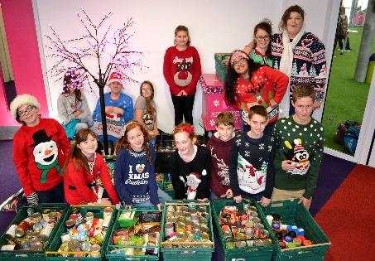

November 2016

Dear Parent/Carer

Non-uniform Day – Christmas Jumper Day

Following the success of last year’s ‘Christmas Jumper Day’ we are once again hoping to raise lots for worthy causes. This year we will be holding a non-uniform and food drive day on Friday 9 December 2016 for all students.

We would like students to wear colourful Christmas jumpers or they can show their designer flair by decorating an old jumper with tinsel for themselves, we look forward to seeing their ‘designer creations’.

We are asking students to donate £1 and the funds raised will be split between:

- The Parent Voice Team – raising funds for the Osiligi Obaya Primary School (The Maasai Warrior Community, Kenya)
- Hope for Food Charity

We are also asking students to bring in a tin/packet of food or other non-perishable item (ie tin baked beans, jar peanut butter, cat/dog food, soap, toothpaste etc) which we are collecting for the local Hope Foundation providing hampers and presents to local families and also running soup kitchens in and around Bournemouth and Poole. I know some students would prefer to help an animal charity and any pet products will go Waggy Tails at Ferndown.

If you are would like further information, please contact me via the Academy Reception or email me: lisse.burbidge@thebourneacademy.com

Once again, we thank you for your continued support.

Yours faithfully,

Mrs Lisse Burbidge
Anvil – Head of House

