

Everyone is a learner and everyone is a teacher

**The Bourne Academy Development Plan 2016/17 – Disadvantaged Action Plan**

At The Bourne Academy we develop literate, numerate global citizens who ASPIRE:

**A**mbitious, **S**elf-confident, **P**hysically Literate, **I**ndependent Learners, **R**esilient, **E**motionally Literate

“Disadvantaged” or “Pupil Premium” (PP) funding is provided to schools to address the current underlying inequalities and close the attainment gap between children eligible for free school meals (FSM) and their peers. Pupils are eligible for this funding if they have been registered for FSM at any point in the last 6 years or if they are looked after (in care).

From March 2014, the rate of Pupil Premium funding was set at £935 per eligible student.  Funding is based on the number of eligible students at the time of the January 2015 census, rather than the number on roll during the academic year.

The Academy will seek to provide an inclusive education for all students that does not marginalise or disadvantage students from more challenging backgrounds. This approach is also in recognition of the relatively high proportion of students in the Academy who may at some point in their education have been eligible for FSM.

In November 2014, Ofsted stated - *"The group of students who are known to be eligible for the pupil premium achieve well.  In 2014 they achieved comparable grades to the average for similar students nationally and in line with the rest of the school.  This level of achievement is maintained by the school's relentless approach to targeted support for pupils eligible for the Pupil Premium."*

Detailed below are the various interventions the Entitlement Coordinator has put in place to support PP students in the academy:

|  |  |  |  |  |
| --- | --- | --- | --- | --- |
| **Desired Outcome** | **Action** | **How impact will be measured** | **Staff member(s) accountable** | **Deadline** |
| **PP students to have access to the same resources as all non-PP students** | 50% discount on all trips of educational merit for PP students | Amount of PP funding provided to PP students for trips to be collated by CT; impact also measured related to various outcomes proposed by co-ordinators of trips. | CT; ER; Staff involved with trips | On-going |
| PP students to be provided with ad-hoc financial support when teachers identify need for resources e.g. catering equipment, PE kit etc. | Amount of PP funding provided to PP students for resources to be collated by CT | CT; ER | On-going |
| PP Success Evening to be held for all Year 11 PP students to inform parents about how to support students’ revision in the run-up to exams as well as to provide all students with a PP resource pack for each subject they study. | Attendance at PP Success Evening to be recorded by ER; predicted grades in all subjects measured monthly at each Progress Tracking. | ER | March 2017 |
| All Year 11 PP students to be provided with a tablet, pre-loaded with key revision apps and Microsoft Office. | Purchase of tablets to be arranged by CT/ER; SS to set up apps on tablets for students; students’ use of revision apps to be recorded by HODs | CT; SS; ER | August 2017 |
| Monthly PP Meetings to be held between ER, Heads of Department all Year 11 PP students to assess any areas they are struggling in, resources they may need and to gain feedback on lessons. | Attendance at PP meetings to be recorded by ER; feedback forms to be collated and e-mailed out to Heads of Department/ASJ by ER | ER; Heads of Department |  |
| Regular Young Carers group held for all students who have a caring role at home. Students provided with rewards/extra pastoral support/resources where needed. | Progress of Young Carers monitored by AP; progress also monitored after every assessment data deadline | AP | On-going |
| **PP students to achieve a better or same Progress 8 score as the average for non-PP students nationally** | All Y11 PP students to attend Study Club revision sessions for Maths, English and Science and to attend Additional Learning revision sessions in subjects where they are currently not making expected progress. | Study Club/Additional Learning registers to be kept by class teachers; progress of PP students to be monitored in monthly Progress Tracking meetings. | ER; Heads of Department; ASJ | May/June 2017 |
| Heads of Science, Maths, Humanities and English to meet with Entitlement Coordinator each month to discuss PP students with negative progress scores and interventions to be put in place | Interventions and progress monitored through departments’ line managements and Progress 8 data spread sheets. | ER; Heads of Department; ASJ | May/June 2017 |
| Line Managers to discuss individual class’ PP data with teachers; teachers to target key PP students with negative progress each month. | Interventions and progress monitored through departments’ line managements and Progress 8 data spread sheets. | Line Managers | May/June 2017 |
| Assertive Mentoring meetings to be held with every Year 11 PP students to discuss their progress/areas they need to improve/individual support they need | Notes from Assertive Mentoring Meetings to be recorded on Progresso by Assertive Mentors | Assertive Mentors; ASJ | On-going |
| Study skills session x2 to be held by external agency – PP Year 11 students to have priority for places | Progress of PP students to be monitored in monthly Progress Tracking meetings. | KF; ER | April 2017 |
| Small-group revision skills workshops to be held with external agency every Wednesday afternoon (Science, Maths and English focus) | Progress of PP students to be monitored in monthly Progress Tracking meetings. | ER | May 2017 |
| **95% of PP students to make expected levels of progress in Maths.** | STEM mentoring programme run in conjunction with Bournemouth University - undergraduates to support G&T PP students in Maths and Science lessons fortnightly. | Predicted grades in Maths and Science, measured monthly at each Progress Tracking. | ER; FR; AM | May 2017 |
| Higher paper “flashcards” revision resource provided to all PP Maths students in sets 1 and 2 | Mock exam results; predicted grades in Maths and Science, measured monthly at each Progress Tracking. | ER; CR | Mocks – December 2016; May 2017 |
| Foundation paper “flashcards” revision resource provided to all PP Maths students in foundation sets | Mock exam results; predicted grades in Maths and Science, measured monthly at each Progress Tracking. | ER; FR | Mocks – December 2016; May 2017 |
| Maths “exam resource” pack provided for all Maths students, including vital maths equipment for exams/revision | Mock exam results; predicted grades in Maths and Science, measured monthly at each Progress Tracking. | ER; CR | Mocks – December 2016; May 2017 |
| **95% off PP students to make expected progress in English** | All English Literature revision books to be offered to PP students at heavily discounted price | Mock exam results; predicted grades in English Language and English Literature, measured monthly at each Progress Tracking. | NB; ER | Mocks – December 2016; May 2017 |
| All English PP Students to be provided with vocabulary books in an effort to widen vocabulary, with key words provided and space to add extra vocabulary in. | Predicted grades in English Language and English Literature, measured monthly at each Progress Tracking. | NB; ER; SL | May 2017 |
| Targeted PP students to receive literacy tuition to support academic writing (higher ability) – provided by Bournemouth University/external agency | Predicted grades in English Language and English Literature, measured monthly at each Progress Tracking. | ER; NB; HG; SL | May 2017 |
| Targeted PP students to receive literacy tuition to support general writing skills (lower ability) – provided both in lesson by support staff and by Bournemouth University/external agency | Predicted grades in English Language and English Literature, measured monthly at each Progress Tracking. | ER; NB; HG; SL | May 2017 |
| **Improvement in the attendance figures for PP students – Y11 PP students with attendance below 95% to be targeted.** | “Spot prizes” on random day each week for PP students in Attendance Group who are in school that day | Attendance tables, measured each month in Attendance Meetings | JB; ER | On-going |
| £10 shopping vouchers for PP students in Attendance Group who improve their attendance figures between November 2016 and February 2017 | Attendance tables, measured each month in Attendance Meetings | JB; ER | On-going |
| Group trip to Thorpe Park for PP Attendance Group if they improve their group attendance figure between November 2016 and February 2017 | Attendance tables, measured each month in Attendance Meetings | JB; ER | February 2017 |
| Confidential student phone number directory to be piloted with Year 11 PP students so regular contact can be made to ascertain reasons for absence/relay messages about key dates e.g. Saturday revision schools, study clubs etc. | Attendance tables, measured each month in Attendance Meetings | JB; CH | On-going |
| **An increase in the amount of PP students considering Higher Education; no PP students to be NEET after Year 11** | Bournemouth University mentoring programme to run for targeted PP students, discussing post-16 options and supporting students with CV writing, researching post-16 options and general revision techniques | Survey about post-16 options to be completed at the start and end of the mentoring programme; data to be collected about year 11 post-16 destinations throughout 2016/17 in career meetings. | ER; VW | April 2017; September 2017 |
| PP G&T students to be given priority for all trips to university, including Cambridge University, Oxford University, Southampton University and Bournemouth University | Data to be collected about year 11 post-16 destinations throughout 2016/17 in career meetings. | ER; KF; VW | On-going; September 2017 |
| Barcelona Trip for a targeted group of PP/G&T students who complete a six-week resilience building and post-16 programme and who maintain a good AtL, attendance and show progress in their Progress 8 scores in the last term of year 10. |  | ER; KF | September 2017 |
| **An improvement in the Attitude to Learning (AtL) of some targeted PP students** | Targeted Y10 and Y11 PP students to be placed in AtL competitions. Students receive an AtL score each lesson and an average is worked out for the week. Prizes given out for those with an average AtL above 2 and sanctions for those below 3. | AtL data to be collected digitally by ER and reported back to Heads of House | ER; Heads of House | On-going |
| **All staff to be aware of effective interventions for PP students and aware which students they that are PP** | Several CPD sessions to be run throughout the year by ER on Pupil Premium, effective interventions and tackling challenging behaviour. Progress of PP students to be a focus in Subject Leads and Coaching Team meetings. | CPD feedback forms | ER; RB | On-going |
| PP focus for a “book look” in each department | Results of book looks discussed by Line Managers with MA | Line Managers | On-going |
| PP data to be included on all lesson plans and seating plans | Results of lesson observations to be discussed with teaching staff and RB. | Line Managers | On-going |

**Pupil Premium Spending at The Bourne Academy**

Disadvantaged (hereafter Pupil Premium or PP) funding is provided to schools to address the current underlying educational inequalities that exist between PP students and their non-PP peers. Students are eligible for the Pupil Premium funding if: they have been registered for Free School Meals at any point in the last 6 years; they have been in care consistently for a period of 6 months or more (Looked After Children or LAC) or are children of service personnel.

In March 2014, the rate of Pupil Premium funding was increased to £935 per eligible student; the funding for Looked After Children was increased to £1900 per LAC student per year. Funding is based on the number of eligible students at the academy at the time of the January 2016 census, rather than the number of students on roll during the academic year. For the academic year 2016/17, The Bourne Academy will have a Pupil Premium budget of approximately £336,225, although this funding is providing on a financial, not academic, year basis.

**Disadvantaged Spending 2015/16**

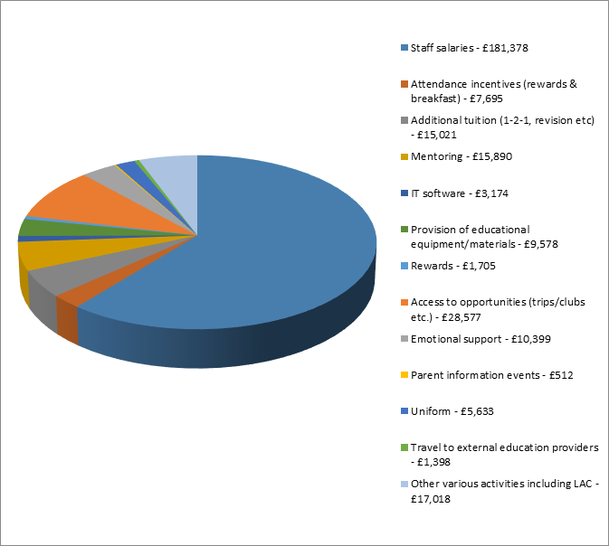

**Disadvantaged Spending Forecast 2016/17**

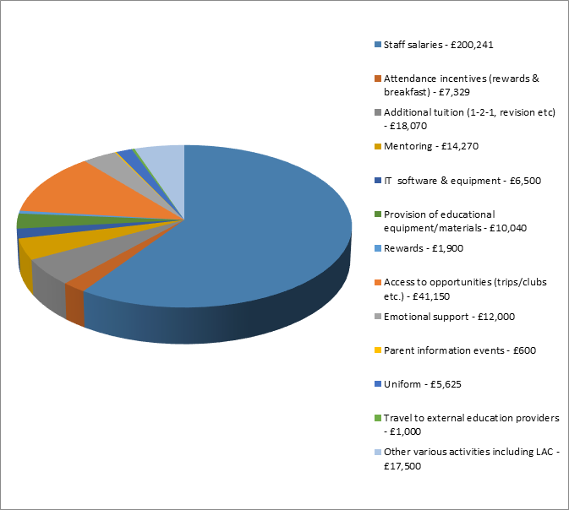

**PP achievement at The Bourne Academy compared to national data**

|  |  |  |  |
| --- | --- | --- | --- |
| **5 A*-C including English and Maths** | **PP Students** | **Other Students** | **Gap** |
| National (3 year average) | 36.10% | 63.57% | -27.47% |
| The Bourne Academy (3 year average) | 43.70% | 61.83% | -18.13% |

As you can see from the above table, regarding attainment (achieving 5 A*-C grades, including English and Maths), PP students at the Bourne Academy have outperformed PP students nationally on average over the last three years, and the attainment gap between PP and Other Students at The Bourne Academy is significantly narrower than the national average gap.

**PP Overall Progress 8 Score**

|  |  |  |
| --- | --- | --- |
| **The Bourne Academy PP Students** | **National Other Students** | **Gap** |
| -0.37 | 0.10 | -0.47 |

**PP Progress 8 Score in English**

|  |  |  |
| --- | --- | --- |
| **The Bourne Academy PP Students** | **National Other Students** | **Gap** |
| 0.28 | 0.08 | +0.2 |

As you can see from the above table, PP students at The Bourne Academy made better progress in English, compared to Other (non-PP) students nationally.

**PP Progress 8 Score in Mathematics**

|  |  |  |
| --- | --- | --- |
| **The Bourne Academy PP Students** | **National Other Students** | **Gap** |
| 0.00 | 0.10 | -0.1 |

As you can see from the above table, PP students at The Bourne Academy did not significantly underperform in Mathematics compared to Other (non-PP) students nationally.