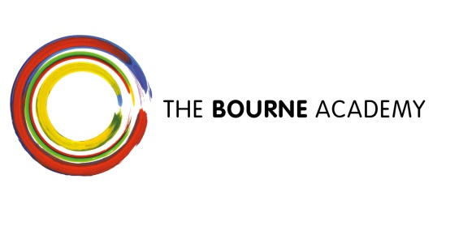

Dear Parent/Carer
Re: Digital Wave Conference Monday 2 October 2017
We have been offered the exciting opportunity to take a group of Computing and Media students to the Digital Wave Conference. The purpose of the event is to raise awareness of not only digital courses and career possibilities within the UK, but the wider opportunities lying ahead in the digital world. The concept for the day is that it should be fun, interactive and reflective of the opportunities to be had in the industry. At the event, students will be able to find out more about the many options available in digital media – from creative and technical roles to marketing and management.
We have been fortunate to secure funding from Digital Horizons for a bus to transport students on the day. Students will be taken from the Academy to the BIC for a 10:00am start. We will depart from the BIC at 2:30pm and students will be returned to the Academy. Students will need to bring a packed lunch and those who receive free school meals will have theirs provided. Students must wear school uniform.
Please can you complete the form below and return it to Mrs Woodings as soon as possible. Seats will be allocated on a first come first served basis. If you have any further questions or concerns please do not hesitate to contact me on 01202 528554 or by email Vicky.woodings@thebourneacademy.com
Yours sincerely

Vicky Woodings
Head of Careers, Employability and Enterprise
……………………………………………………………………………………………………………………………………
(please return to Mrs Woodings or Media/computing teachers by Friday 22 September 2017)
Student Name:………………………………………………………………. Tutor group……………………..

I give permission for my son or daughter to attend the Digital Wave Event on 2 October 2017

I will need a packed lunch provided for me ………. (Please tick)
My emergency conatct number on the day will be:…………………………………………………….

