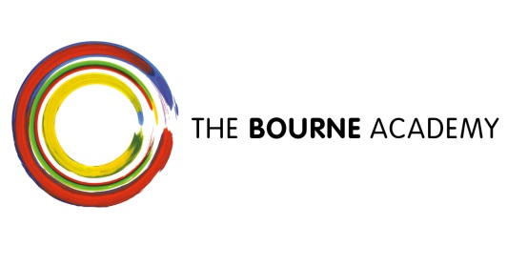
October 2016

Dear Parent/Carer,

I am writing to notify you of some changes to the way we report your child’s academic progress.
We will no longer be issuing you with a written annual report. Instead, we will be providing you with an additional Parent and Teacher Consultation (PTC) evening, meaning that you will be able to meet with your child’s teachers on two occasions across the academic year, instead of just once. The dates are as follows:
 | First PTC: | Second PTC:
Year 7 | 19th October 2016 | 14th June 2017
Year 8 | 25th January 2017 | 28th June 2017
Year 9 | 8th February 2017 | 12th July 2017
Year 10 | 23rd November 2016 | 10th May 2017
Year 11 | 9th November 2016 | 8th March 2017
Year 12 & 13 | 28th September 2016 | 22nd February 2017

We believe that this will give you the opportunity to gain a better understanding of your child’s strengths and areas to improve, as well as strengthening your relationship with their teachers.
We will continue to send you a progress report at the end of each term. This will provide you with detailed data around your child’s attainment, attitude to learning and attendance.

Yours sincerely

A. St John

Mr A. St. John
Assistant Vice Principal

