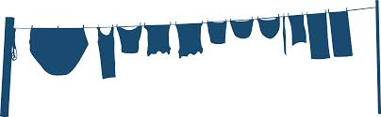

School trip kit list
❑ Towel for showering
❑ Pyjamas
❑ Underwear & socks
❑ Swimwear
❑ Warm, lightweight jumpers
❑ T-shirts
❑ Light, loose-fitting trousers not jeans for activities
❑ One complete change of clothes to keep dry (just in case of poor weather)
❑ Old trainers to wear that can get wet
❑ Trainers or comfortable shoes for other activities
❑ Waterproof jacket
❑ Toiletries - shampoo / soap/ toothpaste etc.
❑ Sunhat / woolly hat
❑ Sunscreen
❑ inhalers
❑ Plastic water bottle
❑ £1 coin for locker
❑ Duvet/Sleeping bag and pillow

ALL OTHER MEDICATION MUST BE CLEARLY LABELLED WITH NAME, DOSAGE AND TIME REQUIRED IN A SEALABLE PLASTIC BAG AND HANDED IN TO YOUR HEAD OF HOUSE ON THE DAY OF DEPARTURE

Optional extras

❑ £10 maximum for sweets / souvenirs
❑ Small rucksack
NO ELECTRONIC DEVICES INCLUDING MOBILE PHONES. Pay phones are available and Heads of House have a phone to contact home where required.

