Parent Voice Fundraising Successes

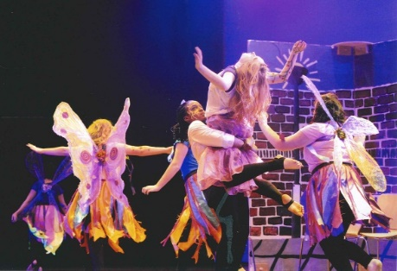
Rock Challenge
In 2013, 2014 & 2015, Parent Voice donated £500 to enable students to take part in Rock Challenge which is a national school competition. This was an amazing experience for the students.

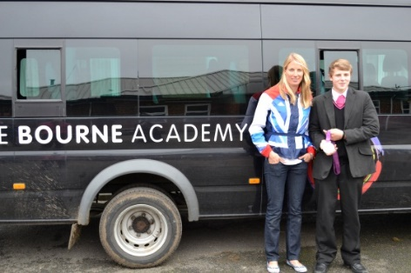
Two Academy minibuses
Thanks to Parent Voice the Bourne Academy now has two mini buses. One that was completely paid for by Parent Voice in 2011 (as shown in picture) and in 2014 another one, with wheelchair access, towards which the Parent Voice team donated £10,000 pounds and which was further funded by The ValentineTrust, for £5000.

The Bourne Academy Prom
Parent Voice kindly agrees to help with the annual Bourne Academy prom. In 2016, they donated £400, which helped the students have a fantastic and sophisticated event held at The Hilton Hotel, in Bournemouth.
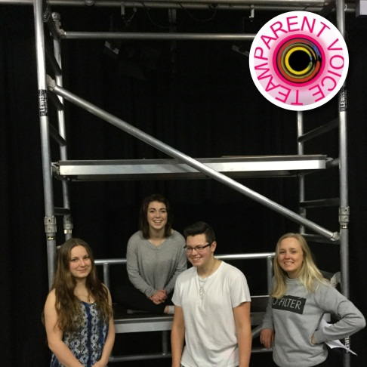
New Scaffold Tower – January 2016
Thank you for the £500 donation and for supporting both the Performing Arts team and the Site Team with the purchase of a new scaffold tower – this improves the quality of our performances no end, as we can get higher lighting installed, safely.

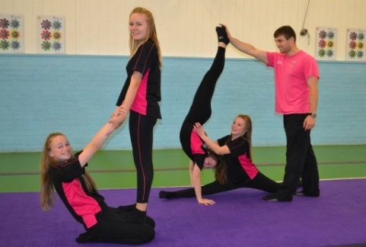
New Gym Mats - 2015
Thank you PVT for kindly donating £400 towards much needed new gym mats in the Sports Department – nice bright colours as you’d expect at The Bourne Academy.

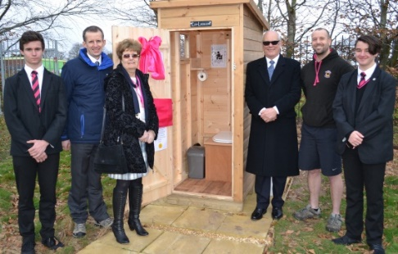
New Eco Loo and Solar Light - 2017
Thank you to the PVT to contributing £230 towards a new Eco Loo and Solar Light for our Outdoor Education Site. This Eco Waterless Compost Toilet requires no plumbing and not only teaches students to be eco-friendly, but keeps them in lessons for longer (saving the long walk back to Academy loos!).

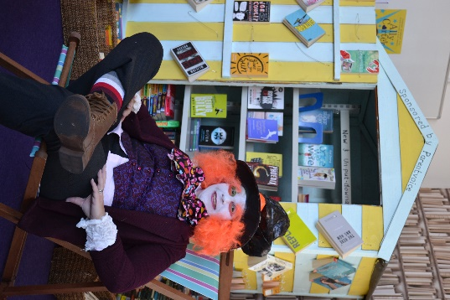
Other donations during 2016-2017
Library ipad, beach hut (new book storage) and two chairs - £600
Sponsorship of Alumni event - £75

