

Re: Pastoral Support Worker

Start Date: September 2018

Thank you for your enquiry. This is a key role within the Academy where you will provide support for the pastoral staff and Heads of House. The House system underpins everything we do and so this role will be at the core of everything we do in order for our students to be successful.

The Bourne Academy is a busy place of learning and work and therefore the ability to organise and prioritise tasks is a key requirement. You must also enjoy working with young people and be prepared to model the ethos of the Academy.
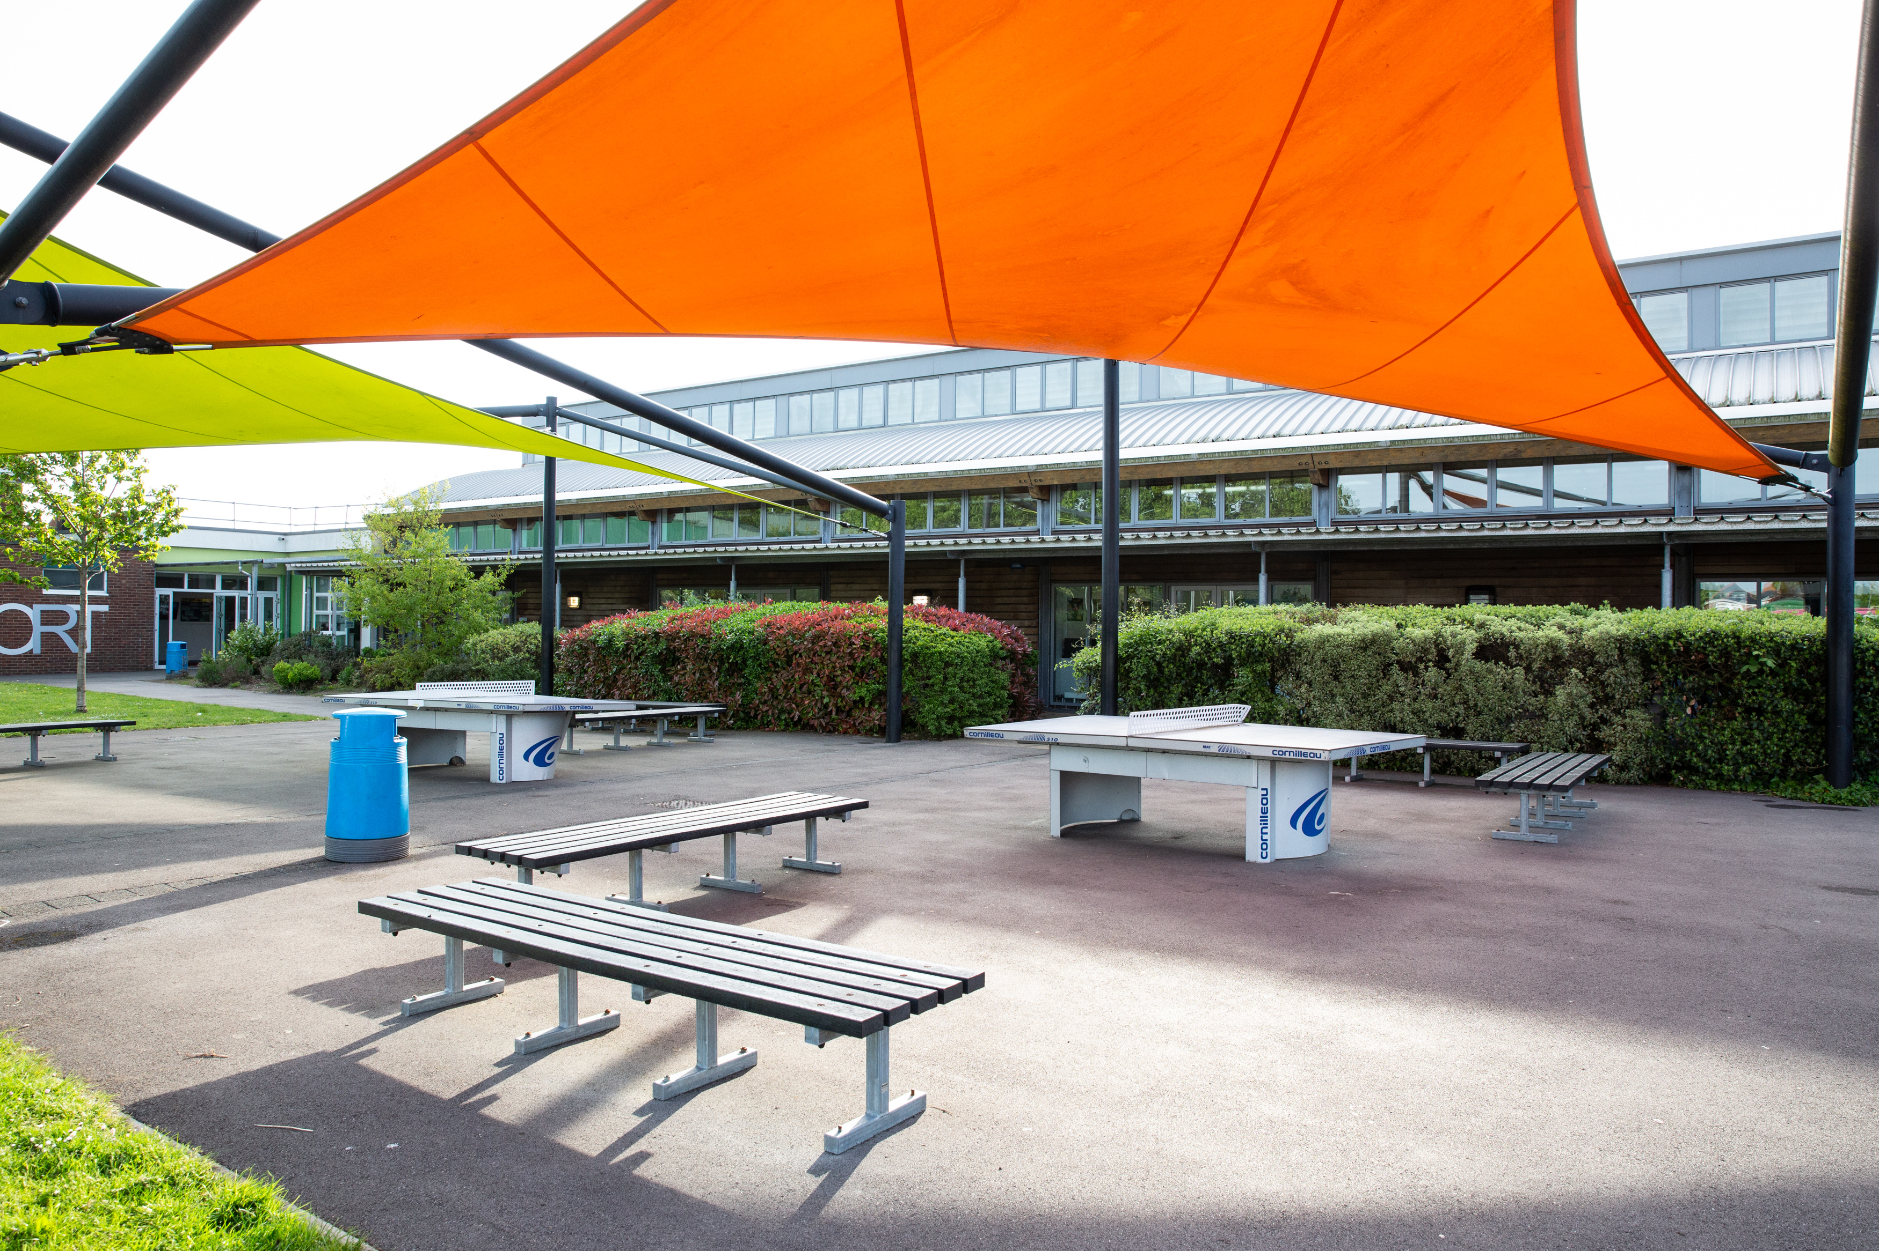
The Bourne Academy has received wide recognition for the improvement that has taken place in recent years and our GCSE results for 2014 placed the Academy as the 5th highest performing within our 55 similar schools in the Country. Our 5+A*-C GCSE grades including English and Mathematics has increased significantly to 58% (22% in 2 years). English A* to C results are 88% (79% first entry) with 3 or more levels of progress being 90% and 4 levels of progress being 47%.

The Academy was last inspected by OFSTED in October 2014 and concluded that The Bourne Academy was a ‘good school’. The report highlighted the following;

- “The quality of teaching is consistently good with some outstanding teaching”
- “Students’ behaviour is good both in and out of lessons.”
- “Relationships are characterised by respect for all. Students and staff are proud to belong to the Academy.”
- “The high attendance is illustrative of how much they (students) enjoy school.”

These are very exciting times for The Bourne Academy. Whilst there has been a lot of improvement in recent years, there can be no room for complacency. We are aiming for excellence. This is a wonderful opportunity to join a strong and dedicated team of professionals and to help enhance the successes in this important subject area. This post will be demanding and very rewarding. If you possess the qualities listed above and have the necessary skills and experience, we will welcome your application.

Safeguarding Children

Please note that The Bourne Academy is committed to safeguarding children. In line with our Safeguarding Policy, we adopt safe recruitment procedures and always check the suitability of applicants to work with children/young people through the appropriate authorities. Only applications submitted on the Academy’s application form will be considered and the successful applicant will be required to undertake an Enhanced Disclosure by the Disclosures & Barring Service. It is our normal procedure to request references on shortlisted candidates prior to interview.
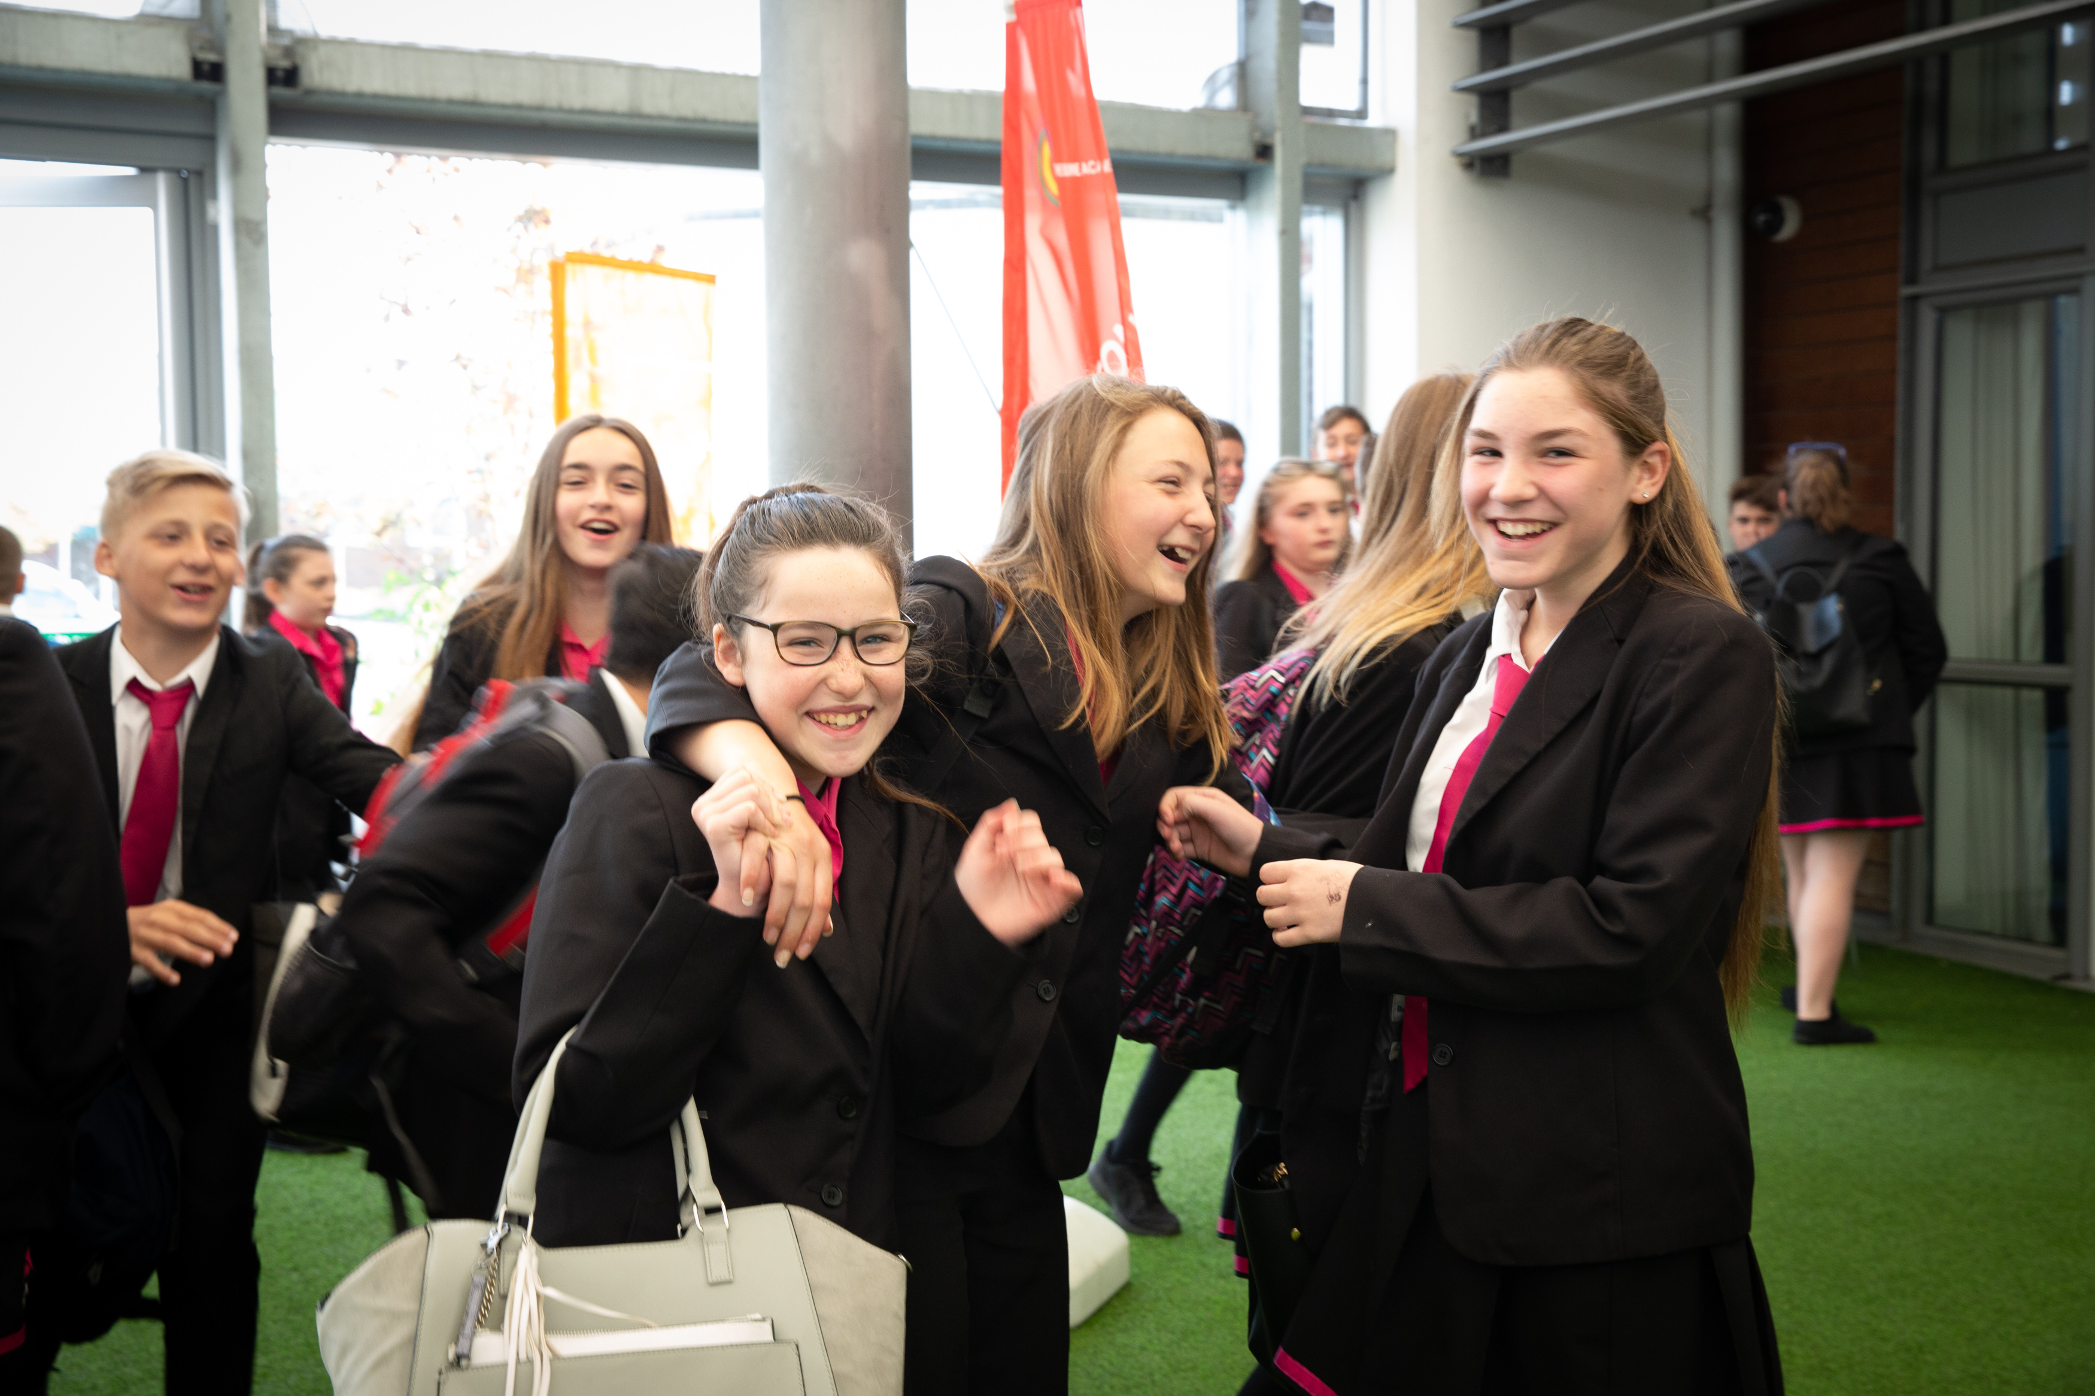
The Interview Process

If selected, the interview process will test and assess your fulfillment of the requirements for this position. You will be expected to attend a panel interview. The interview process will include consideration of your suitability to work with children and the interview panel will ask questions on safeguarding children/young people.

We look forward to your application.

Yours sincerely


Mr M Avoth
Principal

