

March 2019

Thank you for your enquiry. We are seeking to appoint an additional talented, dynamic and innovative teacher for the post of Teacher of Mathematics. This post can be full time or part time and is a permanent post.
We would welcome new starters to join us for the Summer term to bed in and be ready for the new academic year, however we are happy to wait until September 2019 for the right candidate.

The Bourne Academy has received wide recognition for the improvement that has taken place in recent years and our GCSE results in English are particularly strong.
Maths enjoyed record successes in 2018 achieving 69% grade 9 to 4 grades and a Progress 8 score of + 0.20. However, indications for this year are that we will outperform these results. The department is stable and well supported, in terms of resources, and opportunities for staff to develop their teaching and further their careers. As a member of the team you will be supported by a Subject Lead and an experienced Director as well as having a number of responsibility holders within the team.
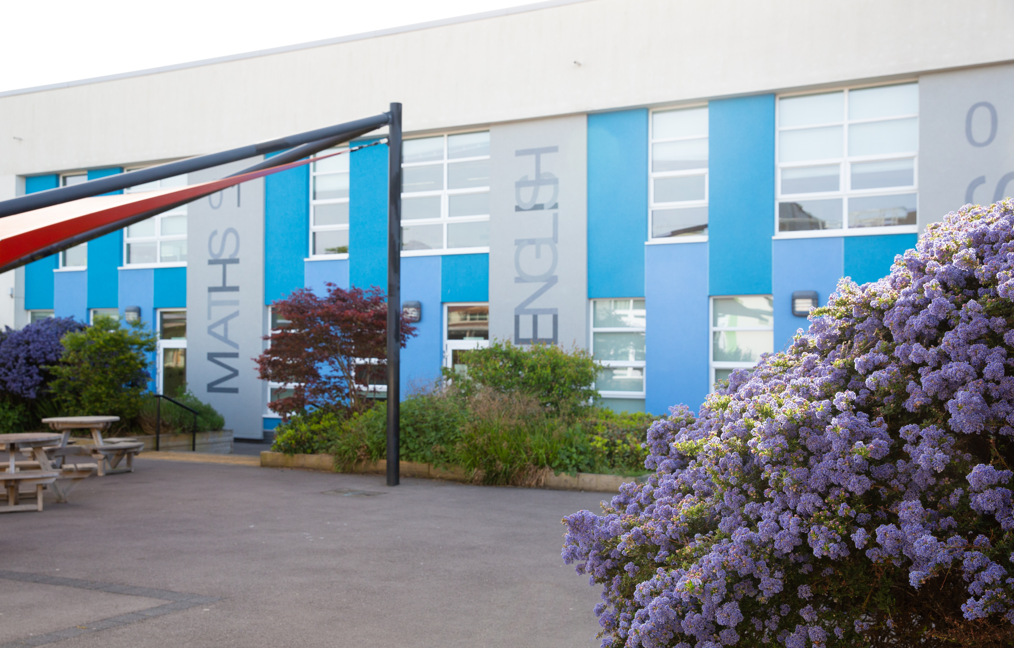

As mentioned earlier, The Academy was last inspected by OFSTED in February 2018 and concluded that The Bourne Academy was a ‘good school’. The report highlighted the following;

- ‘the Academy engages well with parents and the local community, understanding the importance of reaching out to secure support for different aspects of the school’s work. As a result, and with good reason, the school is held in high regard by parents and local employers’
- ‘Pupils are safe in school and reported to inspectors that they feel safe. This is because they do not feel intimidated by other pupils and feel that everywhere in school is a safe place’
- ‘All pupils who spoke with the lead inspector said they would be happy to speak to members of staff if they had worries. Pupils do not think that bullying is an issue at this school and, if it does occur, it is dealt with effectively’
- ‘Students in the sixth form are progressing well. They value the academic and pastoral support they receive from staff and are loyal towards the school. They benefit from positive relationships with staff’
- ‘Staff are rightly proud of the increasing number of students who have achieved places at ‘Oxbridge’ and Russell Group universities. This is, in part, because of the helpful partnership with the school’s sponsor, Canford School. It is also because of the work staff are doing to raise students’ aspirations’

At The Bourne Academy we will develop literate, numerate global citizens who ASPIRE, ie are: Ambitious, Self-confident, Physically Literate, Independent Learners, Resilient, Emotionally Literate.

We want to help students to:
- Have belief in and a positive vision for themselves, their future and their school
- Be literate and able to communicate ideas clearly and confidently
- Think clearly and be able to question, make decisions and solve problems
- Understand and apply engineering and design principles to make life better for people
- Be well prepared to participate in the community and as a global citizen

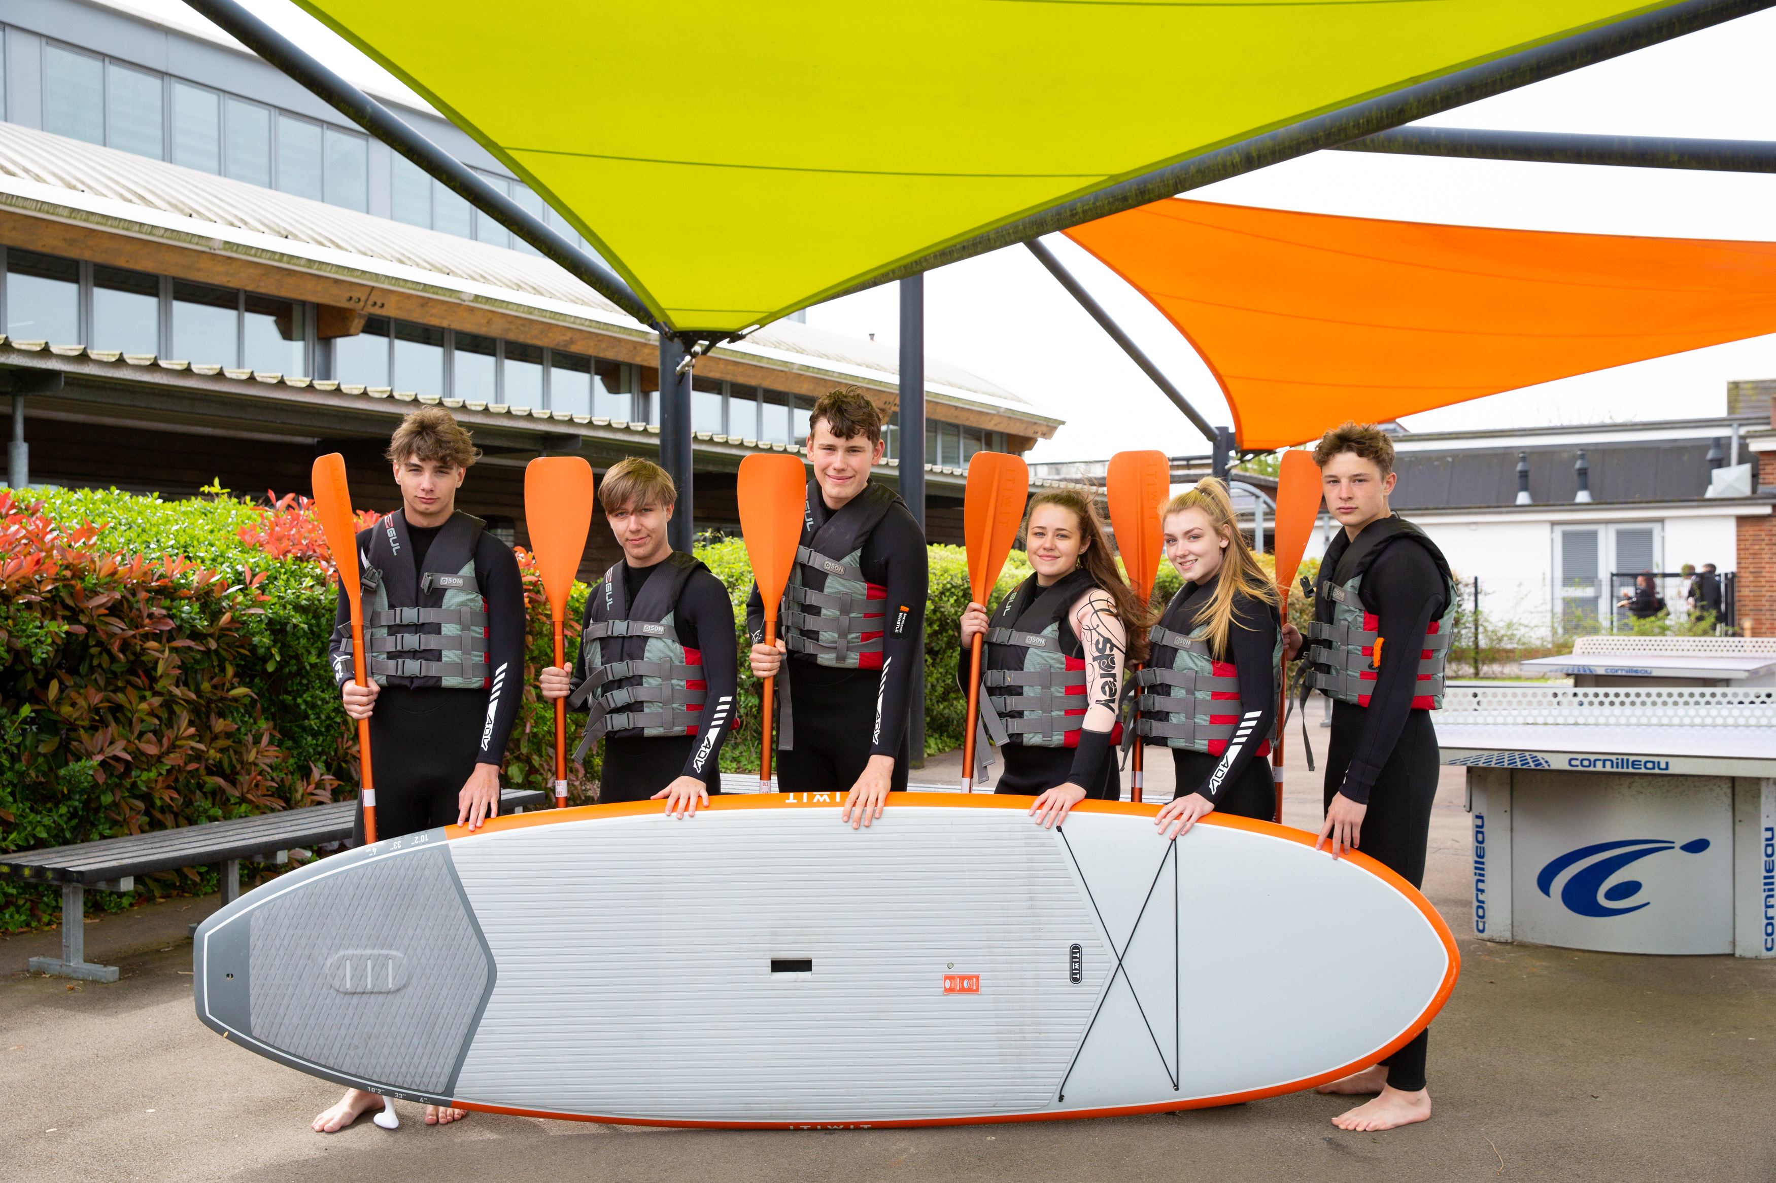

Students are assessed through subject-led ASPIRE DAYS. They spend the day working in teams on various projects, and they take part in many various activities, according to the theme.
Several schools have a House system underpinning their pastoral care, but very few have as many as eight Houses. Ours, named after lighthouses along the south coast, are small enough that the Heads of House, each of whom is only on a 50% timetable, can get to know each student and their parents/carers personally.

Relationships within the House are strengthened through regular House assemblies and internal competitions which also provide an opportunity for friendly rivalry between the Houses.

The Academy’s House system is named after the lighthouses standing at various points along the south coast, providing illumination, aide navigation and safe harbour for mariners and wayfarers. At The Bourne Academy we aspire to do likewise for all our students.

Houses Names: Anvil, Calshot, Eddystone, Hurst, Kingswear, Portland, Sovereign, Trinity

Every individual, their needs and aspirations, are important. The Academy values every child and every adult associated with it. We aim to create a culture in which every person is treated with dignity and respect. Accordingly, good behaviour is expected. The vertical House Tutor relationship is the foundation of the Academy’s care, fostered by daily contact in tutorials.

Additional staff benefits
- Free breakfast every morning for staff
- Lunch provided every Wednesday for staff
- Child care vouchers
- Bike to work scheme
- Bursaries available for professional development
- Comprehensive and highly effective CPD programme
- All teaching staff are assigned a coach

These are very exciting times for The Bourne Academy. Whilst there has been a lot of improvement in recent years, there can be no room for complacency. We are aiming for excellence. This is a wonderful opportunity to join a strong and dedicated team of professionals and to help enhance the successes in this important subject area.
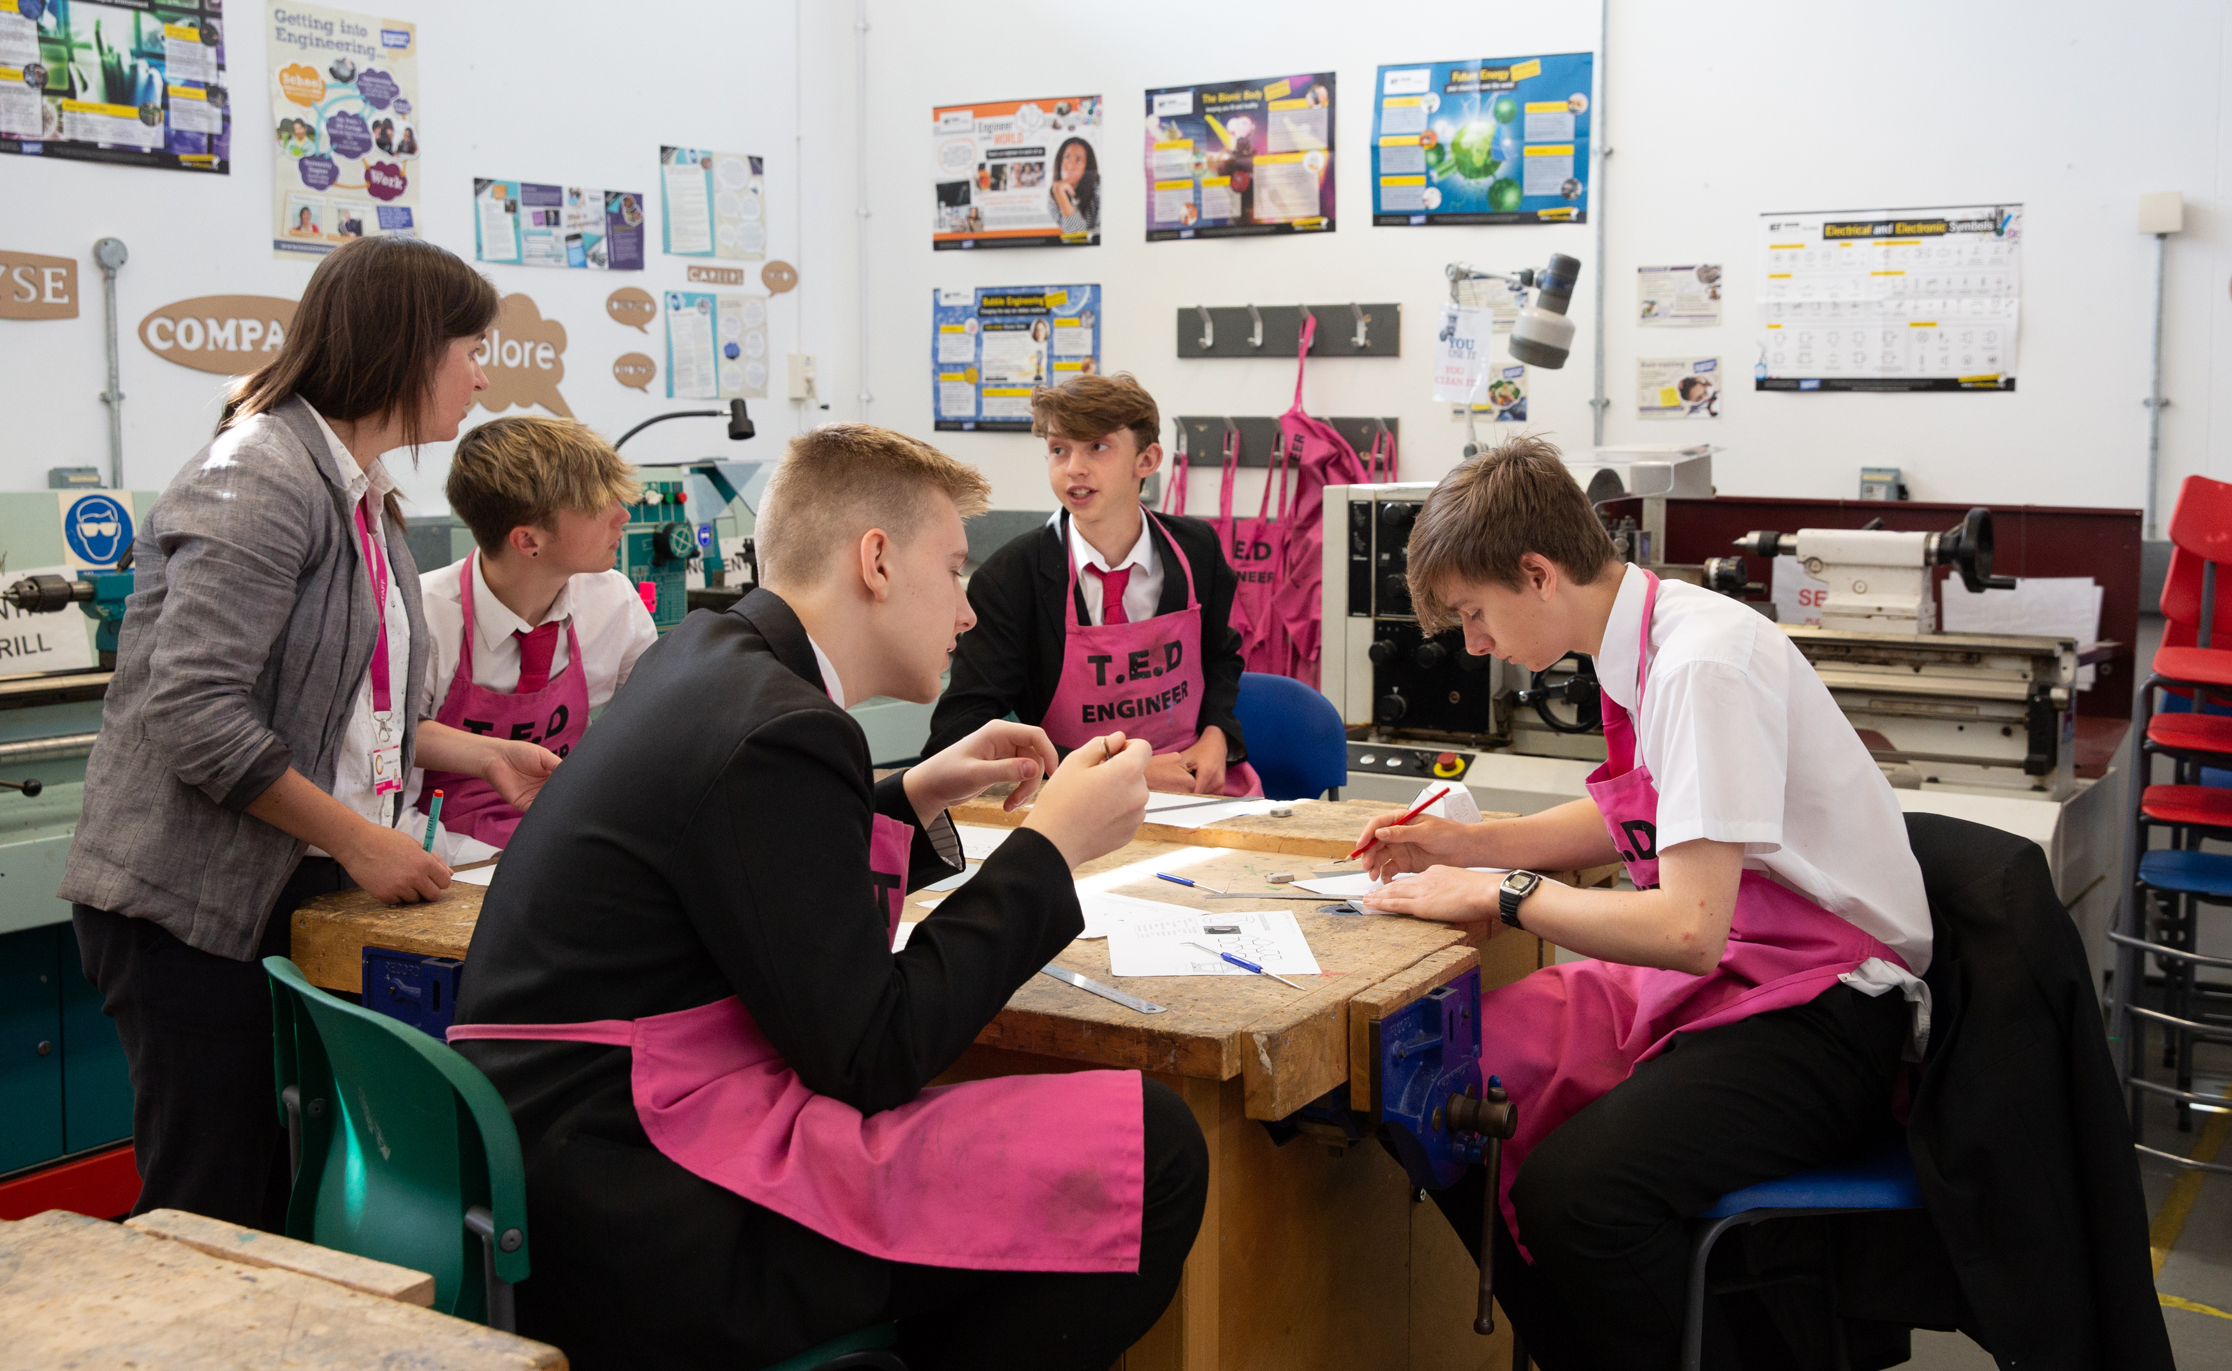
Applications

Please find enclosed an application form, job description and person specification. Further information can be obtained from the Academy’s website at www.thebourneacademy.com

If you would like to visit the Academy prior to making an application, please contact Finola Gilson on 01202 636991.

Safeguarding Children

Please note that The Bourne Academy is committed to safeguarding children. In line with our Safeguarding Policy, we adopt safe recruitment procedures and always check the suitability of applicants to work with children/young people through the appropriate authorities. Only applications submitted on the Academy’s application form will be considered and the successful applicant will be required to undertake an Enhanced Disclosure by the Disclosures & Barring Service. It is our normal procedure to request references on shortlisted candidates prior to interview.

The Interview Process

If selected, the interview process will test and assess your fulfillment of the requirements for this position. As part of this process, you will be observed teaching a lesson to a class/group of students. You will also be expected to attend a panel interview. The interview process will include consideration of your suitability to work with children and the interview panel will ask questions on safeguarding children/young people.

We look forward to receiving your application.

Yours sincerely


Mr M Avoth
Principal

