
March 2020

Thank you for your enquiry. We are seeking to appoint a talented, dynamic and innovative teacher for the post of Subject Lead Food. This post is a full- time/part-time(80%) permanent post.

Food and Catering falls under our STEM and Wellbeing umbrella at the Academy and the subject is delivered with generous curriculum time. The subject is taught from Year 7 through to Year 11. The department is well supported and the subject area consists of two well equipped catering rooms with good teaching and cooking space. As a member of the team you will be supported by a Director of Learning and work with a small team of experienced teachers. The department has a full time subject specific technician.

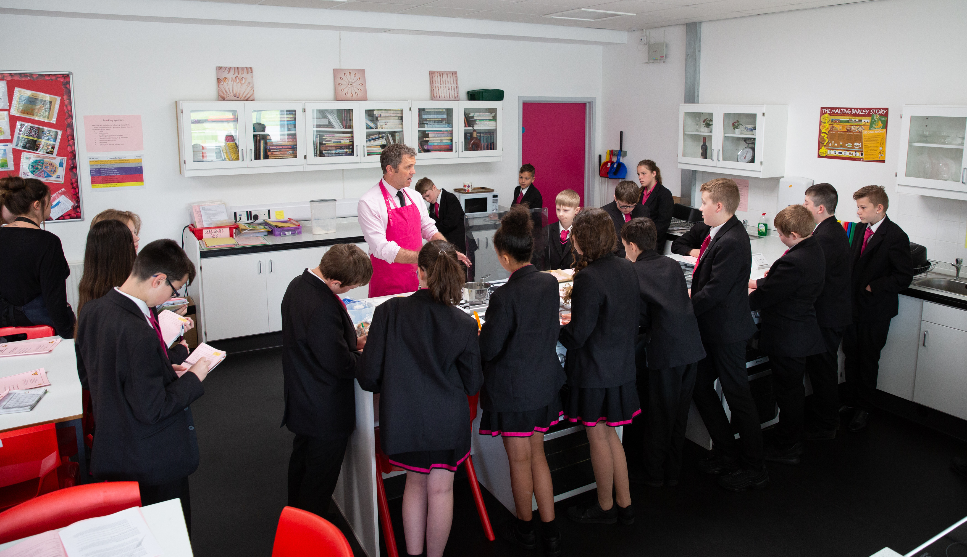

As mentioned earlier, The Academy was last inspected by OFSTED in November 2019 and concluded that The Bourne Academy was a ‘good school’. The report highlighted the following;
- The Bourne Academy is a welcoming and inclusive school. Pupils and staff are proud to be members of the school community. The views of many pupils are reflected in the comment, ‘The school helps me to be the best version of myself.’
- The school is a calm, yet vibrant, place to learn. Pupils are respectful, friendly and polite.
- Leaders’ ambition for pupils to ‘aspire’ runs deeply throughout the school. It is reflected in the design of the curriculum and pupils’ subject choices.
- Sixth-form lessons have many strengths. Teachers have good subject expertise. Students are scholarly and ask and answer complex questions in class. Sixth-form leaders and staff know students well. Staff carefully track students’ attendance, wellbeing and progress. The careers lead provides effective guidance for students’ futures. Staff value all pathways equally and celebrate their students’ successes.

At The Bourne Academy we will develop literate, numerate global citizens who ASPIRE, ie are: Ambitious, Self-confident, Physically Literate, Independent Learners, Resilient, Emotionally Literate.

We want to help students to:
- Have belief in and a positive vision for themselves, their future and their school
- Be literate and able to communicate ideas clearly and confidently
- Think clearly and be able to question, make decisions and solve problems
- Understand and apply engineering and design principles to make life better for people
- Be well prepared to participate in the community and as a global citizen



Students are assessed through subject-led ASPIRE DAYS. They spend the day working in teams on various projects, and they take part in many various activities, according to the theme.
Our House system underpins their pastoral care, Ours, named after lighthouses along the south coast, are small enough that the Heads of House, each of whom is only on a 50% timetable, can get to know each student and their parents/carers personally.

Relationships within the House are strengthened through regular House assemblies and internal competitions which also provide an opportunity for friendly rivalry between the Houses.

The Academy’s House system is named after the lighthouses standing at various points along the south coast, providing illumination, aide navigation and safe harbour for mariners and wayfarers. At The Bourne Academy we aspire to do likewise for all our students.

Houses Names: Anvil, Calshot, , Hurst, Kingswear, Portland and Trinity

Every individual, their needs and aspirations, are important. The Academy values every child and every adult associated with it. We aim to create a culture in which every person is treated with dignity and respect. Accordingly, good behaviour is expected. The vertical House Tutor relationship is the foundation of the Academy’s care, fostered by daily contact in tutorials.

Additional staff benefits
- Free breakfast every morning for staff
- Lunch provided every Wednesday for staff
- Child care vouchers
- Bike to work scheme
- Bursaries available for professional development
- Comprehensive and highly effective CPD programme
- All teaching staff are assigned a coach

These are very exciting times for The Bourne Academy. Whilst there has been a lot of improvement in recent years, there can be no room for complacency. We are aiming for excellence. This is a wonderful opportunity to join a strong and dedicated team of professionals and to help enhance the successes in this important subject area. This post will be demanding and very rewarding. If you possess the qualities listed above and have the necessary skills and experience, we will welcome your application. 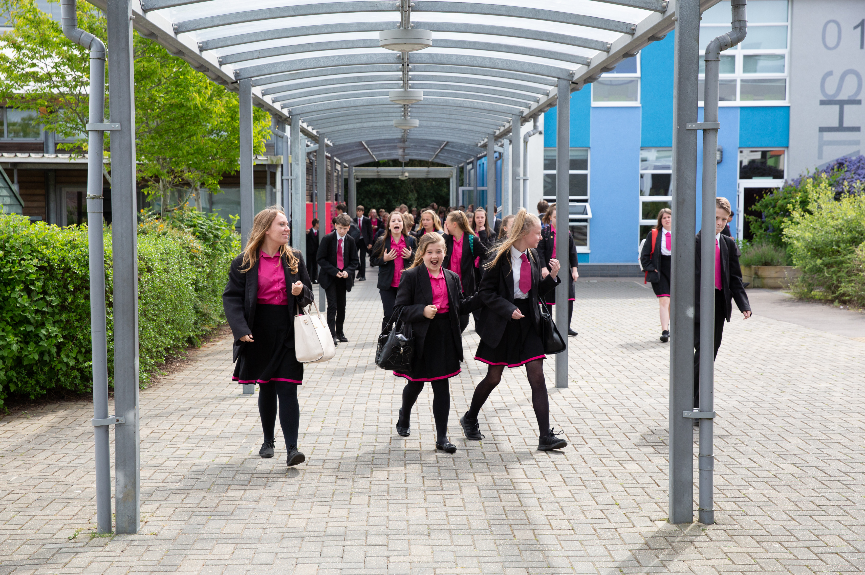
Applications

Please find enclosed an application form, job description and person specification. Further information can be obtained from the Academy’s website at www.thebourneacademy.com

Safeguarding Children

Please note that The Bourne Academy is committed to safeguarding children. In line with our Safeguarding Policy, we adopt safe recruitment procedures and always check the suitability of applicants to work with children/young people through the appropriate authorities. Only applications submitted on the Academy’s application form will be considered and the successful applicant will be required to undertake an Enhanced Disclosure by the Disclosures & Barring Service. It is our normal procedure to request references on shortlisted candidates prior to interview.

The Interview Process

If selected, the interview process will test and assess your fulfillment of the requirements for this position. As part of this process, you will be observed teaching a lesson to a class/group of students. You will also be expected to attend a panel interview. The interview process will include consideration of your suitability to work with children and the interview panel will ask questions on safeguarding children/young people.

We look forward to receiving your application.

Yours sincerely


Mr M Avoth
Principal

