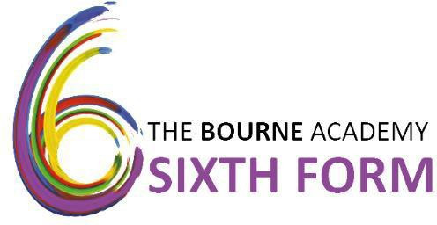

Application Form for September 2021 Admission.
Please return your completed form before Friday 11 December 2020 to: Head of 6th Form, The Bourne Academy, Hadow Road, Bournemouth, BH10 5HS.
Interviews will take place January 2021

PERSONAL DETAILS
(Please complete in black ink and in capital letters)

Surname: | First Names:
Date of Birth: | Male/Female (Please circle)
Current School:
Home Address:

Post Code:
Home Telephone Number:
Mobile Telephone Number:
Email Address:
Name of Parent, Guardian or Next of Kin:
Address, if different from above:

Post Code:

ETHNICITY, RELIGION & HEALTH
The Department for Education has requested that colleges collect this information in order to promote educational and training opportunities for all. It will be treated in strictest confidence and will not be used as part of the selection process.
Ethnicity (please tick)

Description |  | Description
White British |  | Asian/Asian British – Pakistani
White Irish |  | Asian/Asian British – Bangladeshi
Traveller of Irish Heritage |  | Asian/Asian British – Any Asian Background
Portuguese |  | Black/Black British – Caribbean
White Eastern European |  | Black/Black British – African
White Western European |  | Black/Black British Any Other Background
Other White |  | Chinese
Gypsy/Roma |  | Any Other Background
Mixed White and Black Caribbean |  | Korean
Mixed White and Black African |  | Any other Mixed Background
Information not obtained |  | Prefer not to say
Religion (Please tick)

Christian |  | Jewish
Islam |  | Sikh
Buddhist |  | Hindu
Other |  | No religion

Additional Information

Have you lived at the same address for the last 3 years? If not, please give your previous address(es)
Do you have a statement of special educational needs?
Are there any health issues we need to be aware of?
Do you consider yourself to have a disability?

CHOOSING YOUR SUBJECTS

Please rank up to 5 qualifications in order of preference. Students generally will end up studying a combination of 3 A Levels (or equivalent).
Put number 1 next to the subject you most want to study, then a 2 next to your next preferred course until you have selected 5.
A LEVELS:

English Literature |  | Biology
Maths |  | Chemistry
Sociology |  | Physics
Psychology |  | Modern Foreign Languages
Religious Studies |  | Business Studies
Product Design |  | Art & Design: Photography
History |  | Art & Design: Fine Arts
Geography |  | English Language

OTHER COURSES:

Core Maths
Criminology (BTEC)
Digital Film and Video Production BTEC
Music – Rock School Level 3 Subsidiary Diploma
Performing Arts – Acting BTEC (Single)
Performing Arts – Dance BTEC (Single)
Sport BTEC (Single)
Sport BTEC (Triple)
Health & Social Care BTEC (Single)
Health & Social Care BTEC (Triple)
Forensic and Criminal Investigation BTEC (1.5 A Level Equivalent)
Forensic and Criminal Investigation BTEC (double)
Forensic and Criminal Investigation BTEC (triple)
Travel & Tourism (BTEC)

EXAMINATIONS
Please list all examinations you will be taking the Summer Term:

Subject: | Level: (GCSE, BTEC etc.) | Predicted Grade:

Please list any qualifications you have already achieved:

Subject: | Level: (GCSE, BTEC etc.) | Predicted Grade:

PERSONAL STATEMENT

Describe your personality, qualities, interests and the career you would like to follow in the future. You may attach an extra sheet if necessary:

Please give examples of how you give to others. This can be at school, home or the community. You may attach an extra sheet if necessary:

Please explain how you think you will be able to contribute to The Bourne Academy community:

Please list any additional Awards/Qualifications achieved including outside of school, e.g. music, sport etc:

Please supply two referees, one of these must be from your current/last school.

Name: | Name:
Position: | Position:
Address:  Postcode: | Address:  Postcode:
Telephone: | Telephone:

I confirm that all information in this form is true and accurate.

Student Signature

Student Name (Please print)

Date

