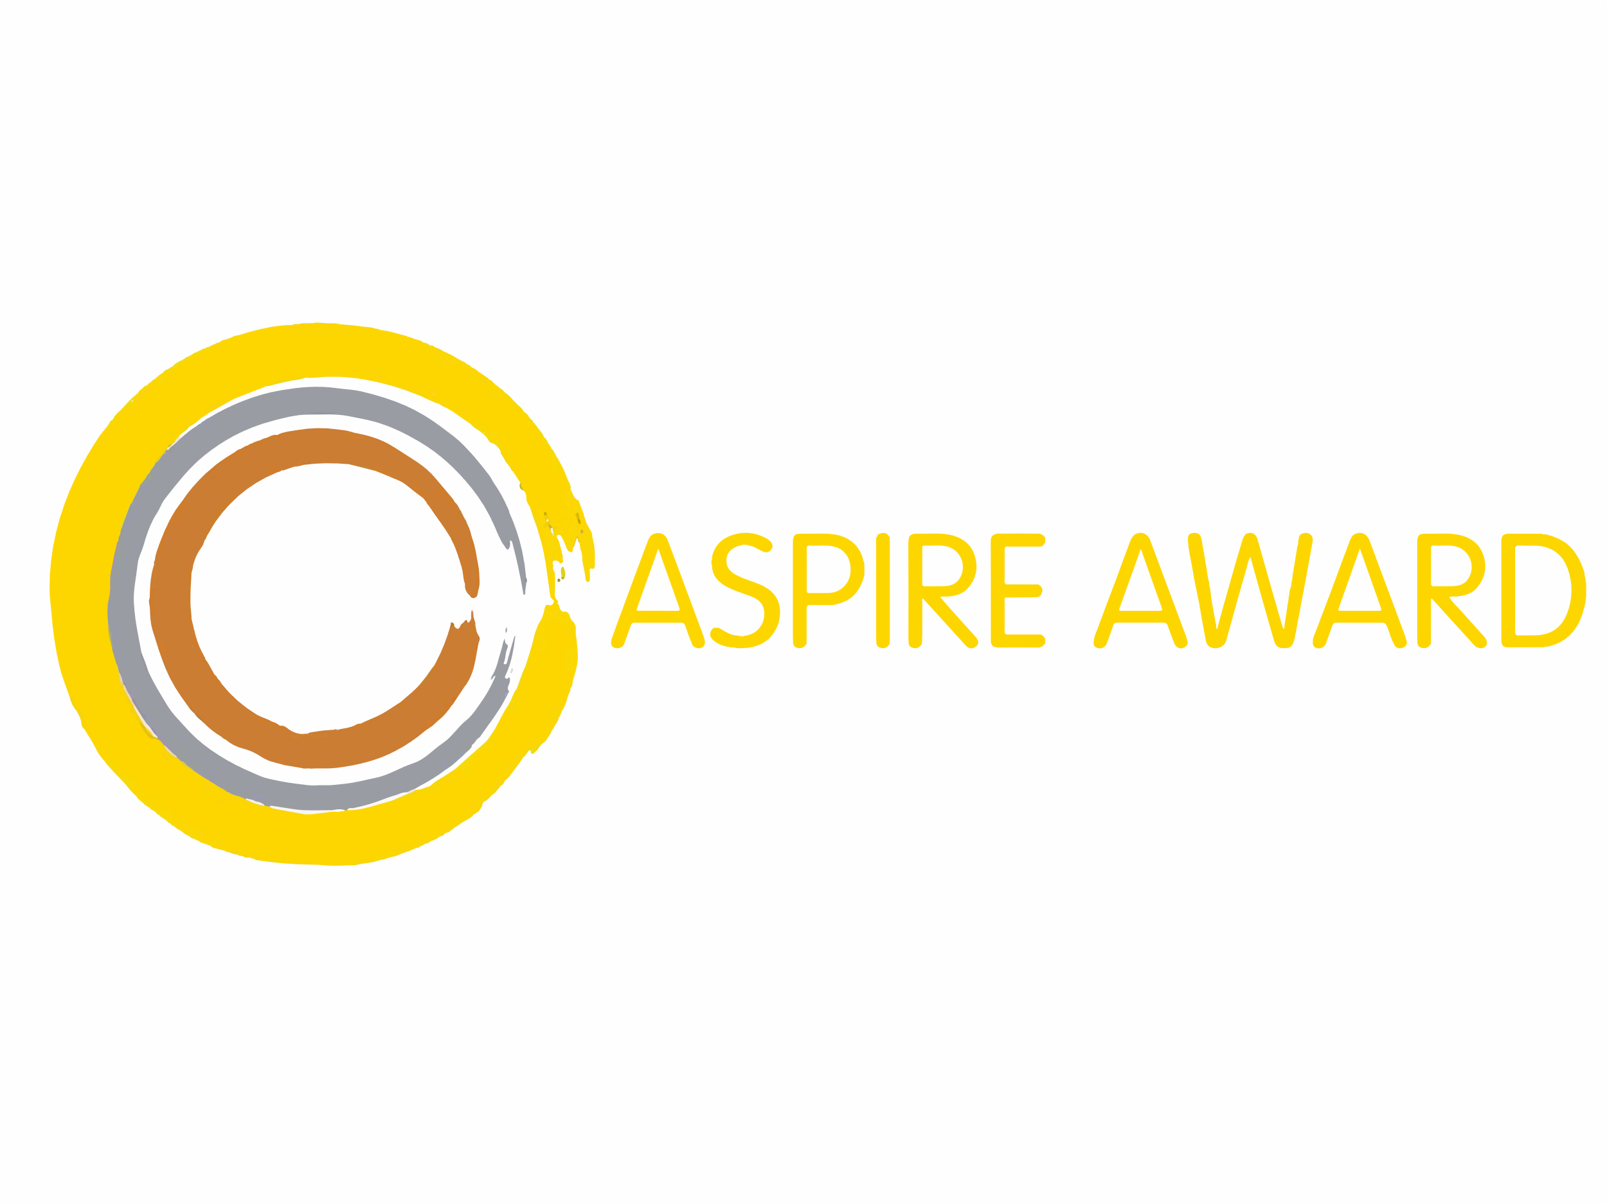

Student Evidence Portfolio

Gold

2024-2025

Deadline for Submission: Friday 11 July 2025 4pm

To submit: Paper copies – to Reception

Electronic copies – Satchel One/SMHW

|  |  |
| --- | --- |
| Full Name |  |
| Tutor Group |  |

|  |  |
| --- | --- |
| Sponsor Name |  |
| Sponsor Signature |  |

|  |  |
| --- | --- |
| Total House Points |  |

Why?

The ASPIRE Award is all about helping you to develop your **character** by focusing your mind on getting involved and making a **positive contribution**.

On competing your award, you will achieve a certificate, an ASPIRE Award badge as well as an invitation to our ASPIRE Award Celebration.

What?

The ASPIRE Award has three levels, bronze, silver and gold. All students will start by completing bronze, and work through the Award during your time at the Academy.

The suggested task list has been created with Student Council and your teachers, but if you are involved in an activity that is not listed, either in school or outside of school, then you should enter the evidence in the ‘Supporting Statement’ box on each page.

How?

Use this booklet to collate your evidence and celebrate your achievements throughout the year. To complete your bronze award, you need to complete a minimum of three pieces of evidence in each competency.

At the end of the year, you will need to ask your sponsor to verify your evidence before it is assessed. This could be a teacher, your tutor or your Head of House.

ASPIRE Award Gold Challenge

Read the two challenge tasks below. You are required to select one challenge task to complete as part of your Gold ASPIRE Award challenge. Both challenges have been designed to develop your ASPIRE Competencies in different ways, and you should select the one that will present the best challenge for you.

|  |
| --- |
| Challenge Option One - Project  Working as a team with other students who are completing the Gold ASPIRE Award you are to design, lead and complete a project. This could be a fund-raising project, a project to raise awareness or to have a positive impact on the community.  You will be able to meet regularly with a member of staff to support you and approve your project to help get started.  Your project will need to be completed in the summer term with your evidence ready for the deadline of the Award. |
| Challenge Option Two – Presentation  Working independently, you will create a prepare and present a presentation that includes the details below with the aim of inspiring younger students to get involved in their community:   * Your ASPIRE journey at The Bourne Academy * Aspects of your development that you are most proud of * Challenges that you have overcome * Your ambitions for the future.   You will present to senior members of staff and student representatives.  The presentations will be completed in the summer term with your evidence ready for the deadline of the Award. |

Notes

Ambitious

|  |  |
| --- | --- |
| Case Study Evidence | Dates |
| Please extend box sizes to accommodate photos and extended writing |  |
|  |  |
|  |  |

Self-Confident

|  |  |
| --- | --- |
| Case Study Evidence | Dates |
|  |  |
|  |  |
|  |  |

Physically Literate

|  |  |
| --- | --- |
| Case Study Evidence | Dates |
|  |  |
|  |  |
|  |  |

Independent

|  |  |
| --- | --- |
| Case Study Evidence | Dates |
|  |  |
|  |  |
|  |  |

Resilient

|  |  |
| --- | --- |
| Case Study Evidence | Dates |
|  |  |
|  |  |
|  |  |

Emotionally Literate

|  |  |
| --- | --- |
| Case Study Evidence | Dates |
|  |  |
|  |  |
|  |  |