June 2026

Dear Parents/Carers,
Subject: Visual Arts End of Year Show 2026

We are delighted to invite you to The Bourne Academy’s Visual Arts End of Year Show 2026, taking place on Wednesday 1 July from 3.00pm–4.00pm.

This exhibition celebrates the creativity, talent, and hard work of our students across the Visual Arts department. The show will feature work from our GCSE and A Level Art, Craft and Design students, showcasing their imagination, technical skill, and personal expression.

This year, students in Years 7–10 are also invited to submit work to be considered for the exhibition, alongside GCSE and A Level work. A couple of pieces from each year group will be selected to be displayed as part of the show. The deadline for submission of work is Friday 19 June.

Students should submit an image of their work via Satchel One.
- Students may submit any artwork, digital art, photography, craftwork, or handmade items such as models or sewing projects.
- Selected pieces will need to be brought into school on Monday 29 June so they can be displayed in the exhibition.
- If the work is digital, the Visual Arts department will print the selected pieces.
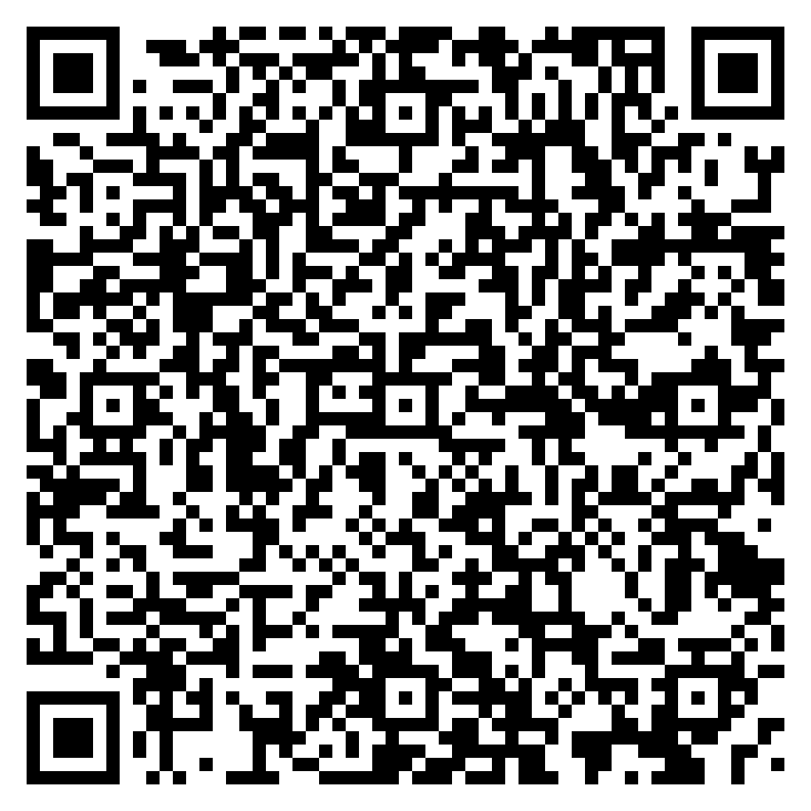
We would love to welcome parents, carers, students, friends, and supporters to the exhibition to celebrate the incredible achievements and creativity of our students.
Tickets are free, but we ask that you register your interest: https://www.ticketsource.com/the-bourne-academy/t-jxrzvpl
We look forward to seeing you there and celebrating another fantastic year of creativity at The Bourne Academy.

Kind regards,
The Visual Arts Department
The Bourne Academy

