Dear Parent/Carer,
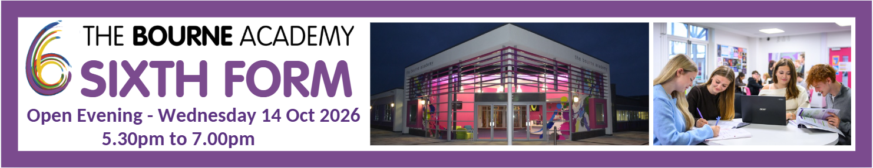
RE: The Bourne Academy Sixth Form Open Evening – Wednesday 14 October 2026
This year marks a significant milestone in your child’s educational journey as they approach their GCSE’s exams and the end of their Key Stage 4 education. We would like to invite you and your child to explore your child future with us at our Sixth From Open Evening.
During the event you will have the chance to see what courses are on offer in our Sixth Form, speak to teachers and get answers to any questions you might have about subjects or general Sixth Form life.
Join us on Wednesday, 14 October from 5.30pm to 7.00pm - we’re excited to showcase the wealth of our Sixth Form offer and to welcome you and your child to our Open Evening.
Kind regards
Mr Dean Taafe

Head of Sixth Form

