

11 September 2026

Dear Parent/Carers,

Academy locker rental

The Academy has a small number of lockers available for rental during the school year. They can be used to store coats, PE kit etc. The cost of renting a locker for each school year is £15.00 and students must provide their own padlock (clasp no wider than 0.5cm). Please see below examples for some padlocks that fit our lockers.

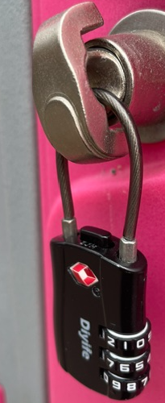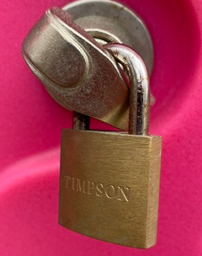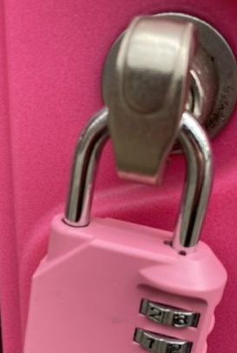

At the end of the year your child will be reminded to remove all items from their locker and take their padlock home.

If your child is interested in having a locker this year, please complete the online form to express your interest by 8am Friday 18 September - Locker Hire 2026/27 – Fill in form
Once expressions of interest have been received, we will allocate lockers out on a first come, first serve basis and contact you to let you know if your child has been allocated a locker and provide details of how to make payment. We will also provide the date that your child must bring their padlock into school to be given access to their locker. Please be aware that payment for the locker must be done prior to the date your child will be given access to their locker.

If your child is allocated a locker then it will be their responsibility to ensure that they bring their padlock key into school with them each day, or remember the code. If the key/code is forgotten, and your child needs access to their locker, then Academy staff will need to cut the lock from the locker to provide access.

If you have any queries, please contact the Finance Department.

Yours sincerely

The Bourne Academy

