

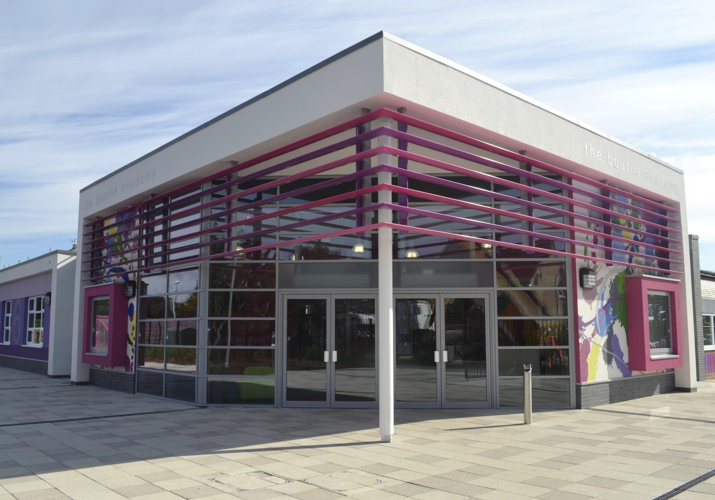


'The school is a calm, yet vibrant, place to learn. Pupils are respectful friendly and polite.' Ofsted 2019

2024



Dear Candidate,

Learning Support Assistant
We want to continue to appoint colleagues who are passionate about education and who want to make a difference for the students in our care, in ensuring a high-quality provision and high standards of progress and achievement for our SEND and CiC students. This role will commence January 2025.

At The Bourne Academy we will develop literate, numerate global citizens who ASPIRE, i.e., are: Ambitious, Self-confident, Physically Literate, Independent Learners, Resilient, and Emotionally Literate.

We will achieve this Vision by:
- Raising aspirations of students, their parents/carers and the community, to foster a sense of self-worth, and reducing absence,
- Developing a culture of Rights & Responsibilities where outstanding behaviour allows all learners to achieve success and all members of the Academy treating each other with respect
- Delivering increased learning opportunities for children resulting in increased opportunities to succeed and improved outcomes and life chances for all so that all leaving students are in employment, education or training
- Raising standards including attainment for all years and in English and Mathematics and other core subjects.
- Ensuring inclusive learning, namely the highest standards of learning and teaching, and a relevant and personalised curriculum for all students
- Being active in the wider education system by sharing the great practice, skills, expertise and facilities that exist within The Bourne Academy and our partner school, Canford to increase the pace of school improvement and deliver improved outcomes; equally seeking out and learning from great practice elsewhere
- Developing great staff and creating opportunities for our staff to contribute to and influence the outcomes of more children more widely that will enhance their learning and further develop effective leaders at all levels
- Ensuring that leadership skills and attributes are fostered and displayed throughout the Academy by staff and students
- Increasing the sharing of facilities, services and provision that enables greater opportunities for our children, their families and our communities to benefit from enrichment activities and that will deliver efficiencies that enable funds to be directed towards Teaching and Learning
- Increasing our resilience and capacity to better plan for, and respond to, the changes needed in education as we all learn to adapt and create new ways to teach and support students and their families.

The Academy was last inspected by OFSTED in November 2019 and concluded that The Bourne Academy was a ‘good school’. The report highlighted the following:
  - The Bourne Academy is a welcoming and inclusive school. Pupils and staff are proud to be members of the school community. The views of many pupils are reflected in the comment, ‘The school helps me to be the best version of myself’
  - The school is a calm, yet vibrant, place to learn. Pupils are respectful, friendly and polite
  - Leaders’ ambition for pupils to ‘aspire’ runs deeply throughout the school. It is reflected in the design of the curriculum and pupils’ subject choices
  - Sixth-form lessons have many strengths. Teachers have good subject expertise. Students are scholarly and ask and answer complex questions in class. Sixth-form leaders and staff know students well. Staff carefully track students’ attendance, wellbeing and progress. The careers lead provides effective guidance for students’ futures. Staff value all pathways equally and celebrate
their students’ successes.
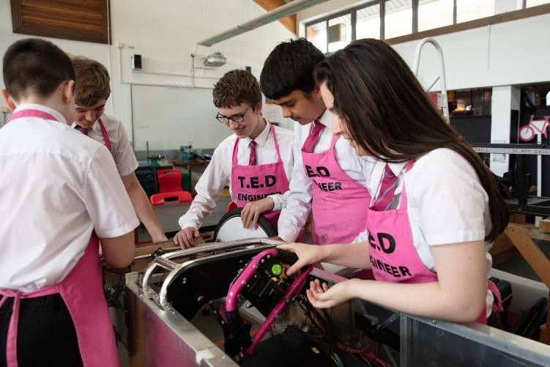


Students ASPIRE competencies are assessed through subject led ASPIRE DAYS. They spend the day working in teams on various projects, and they take part in many various activities, according to the theme. Several schools have a House system underpinning their pastoral care. Ours, are small enough that the Heads of House, each of whom is only on a 50% timetable, can get to know each student and their parents/carers personally.

Relationships within the House are strengthened through regular House assemblies and internal competitions which also provide an opportunity for friendly rivalry between the Houses.

The Academy’s House system is named after the lighthouses standing at various points along the south coast, providing illumination, aide navigation and safe harbour for mariners and wayfarers. At The Bourne Academy we aspire to do likewise for all our students.

Every individual, their needs and aspirations, are important. The Academy values every child and every adult associated with it. We aim to create a culture in which every person is treated with dignity and respect. Accordingly, good behaviour is expected.

Please do get in touch if you would like to have a tour of the Academy prior to submitting your application. We would be delighted to show you around. Our website, www.thebourneacademy.com will also provide further information on the Academy.

These are very exciting times for The Bourne Academy. Whilst there has been a lot of improvement in recent years, there can be no room for complacency. We aim for excellence. This is a wonderful opportunity to join a strong and dedicated team of professionals and to help enhance the successes in this important subject area. This post will be demanding and very rewarding. If you possess the qualities listed above and have the necessary skills and experience, we will welcome your application.

Yours sincerely

Mr Mark Avoth
Principal


